EASY (Experiment Analysis System for Yeast) Manual 17_0611

Running Easy from Matlab
Start Matlab
This manual will be executed a Linux server. Click on the Matlab icon for 2011a in a Linux GUI utility (i.e., Programming→Matlab 2011a) or the executable from the place of your installation.) Set the current folder to that where EstartConsole.m resides i.e., for the Hartman Lab this is /media/data/EASY/InovImager_jwrCF_WINLinx150716devFotoCircImCF02searchCtrlDev .
Click on this start up scrip EstartConsole.m and click the run icon associated with the editor.
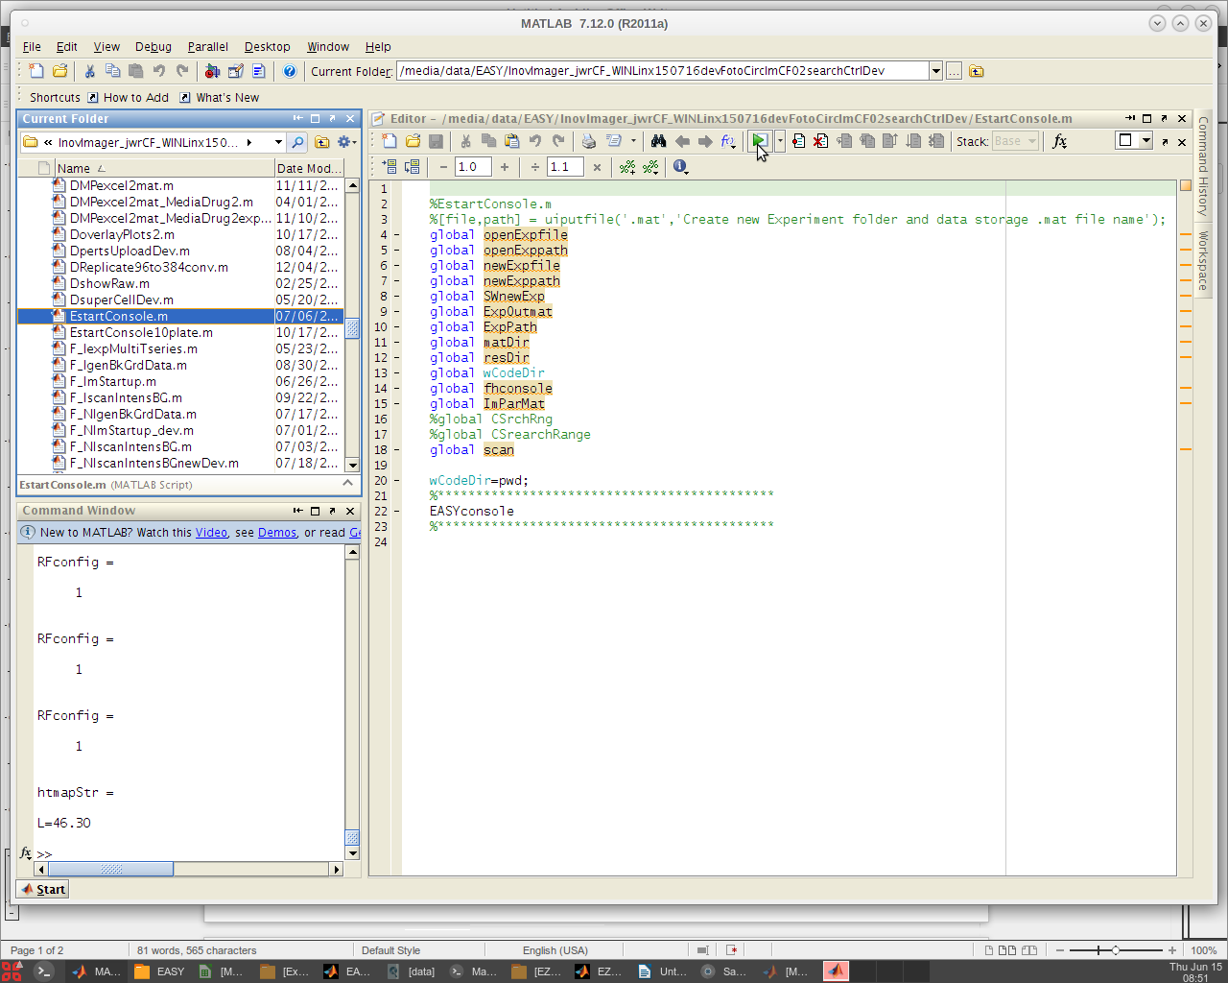

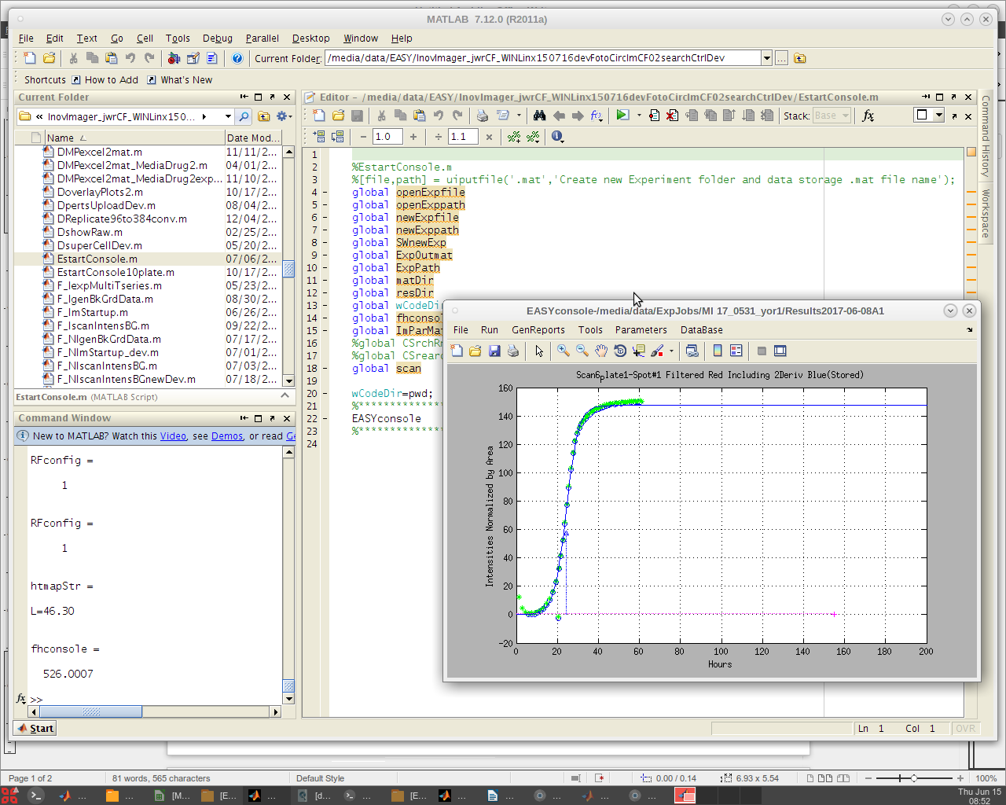

The EASY console GUI appears. This is user interface for quantifying high throughput yeast growth phenotype experiments. Now click on the File menu tab and select 'New Experiment'.
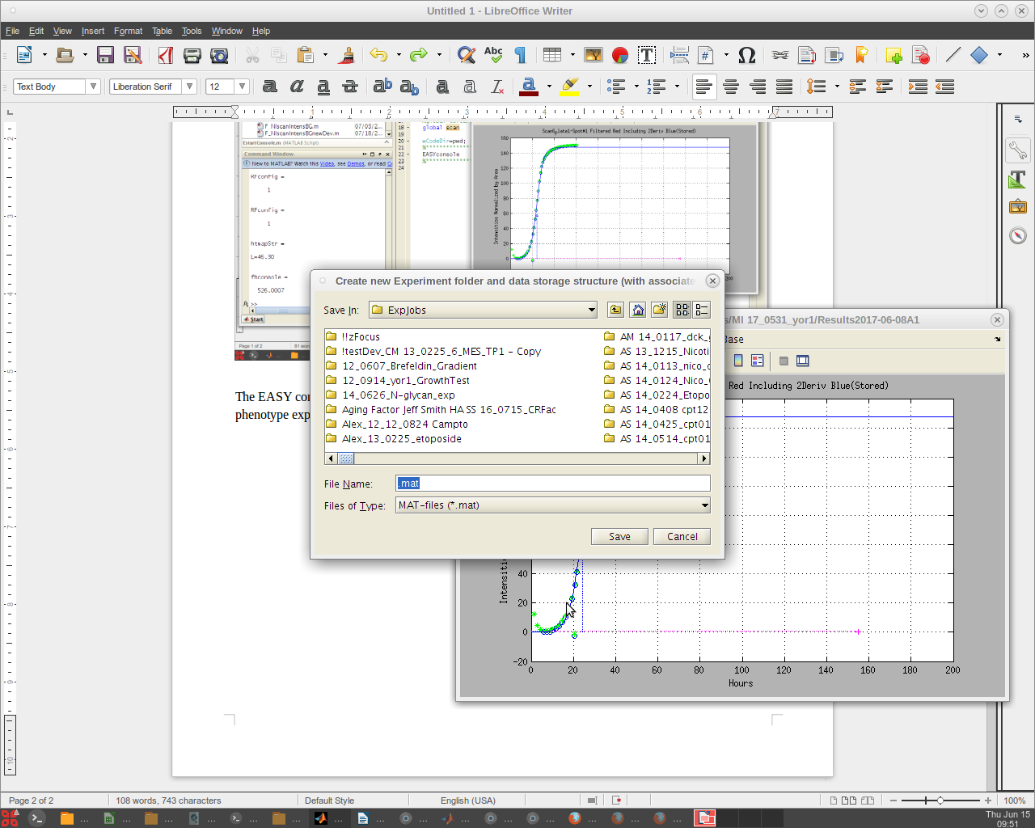
The code been set to go to the /ExpJobs folder. If it does not, simply navigate to where your experiment images and /MasterPlateFiles folder reside. Click on the experiment folder opening it and enter a name to be associated with this analysis. Traditionally A1 is used for this but one could apply any name. The date will be appended to that name and Results to produce a results folder and sub folder structure. These folders will house all the data that is produced by image quantification for this experiment.
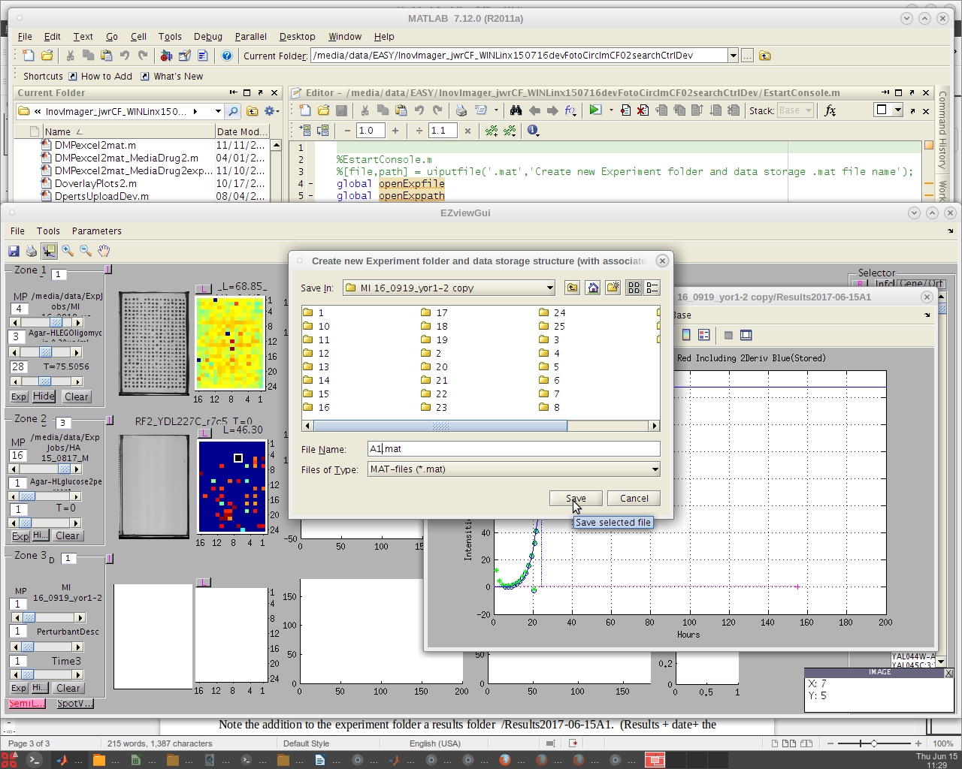
Note the addition to the experiment folder a results folder /Results2017-06-15A1. (Results + date+ the name entered (A1).
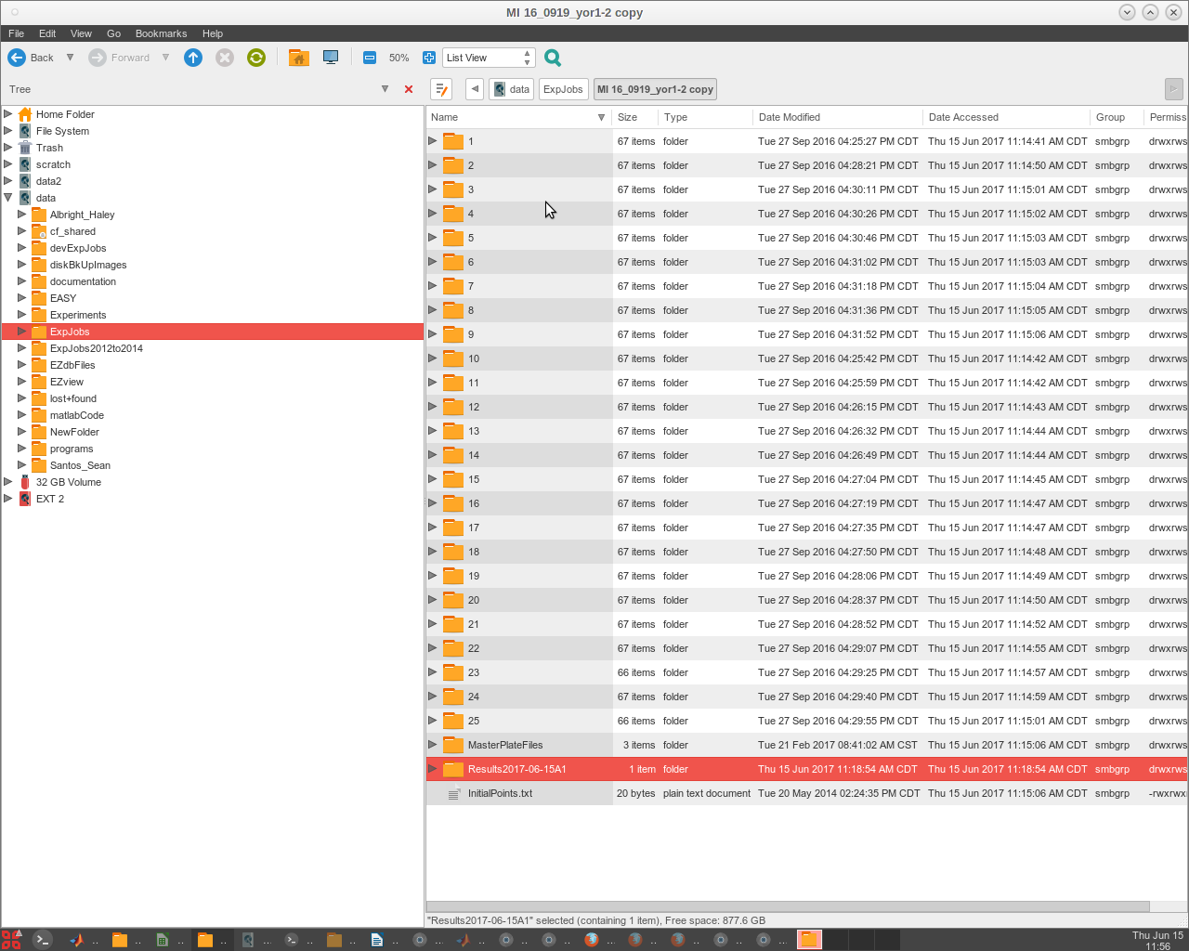
Going inside the results folder, we see sub folders that were created.
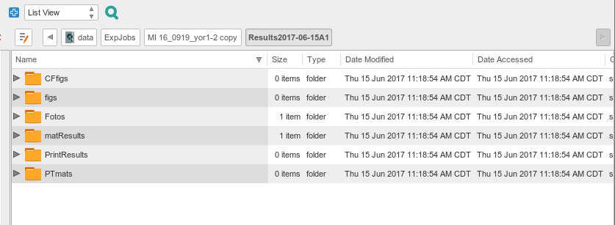

Pin Tool Mapping
Select at least two images from your experiment (or another experiment) to place in a 'PTmapFiles' folder. Sometimes an experiment doesn't have a complete set of quality spots for producing a pin tool map that will be used to start the spot search process. In this case the folder for Master Plate 1 (MP 1) is almost good but has a slight problem. At P13 the spot is extended. We might use this one but would like to include others that are more centered if possible. The other plates with higher drug concentrations could be used, but since a recent experiment has a better reference plate image, we will add it to the set of images to produce the pin tool map.
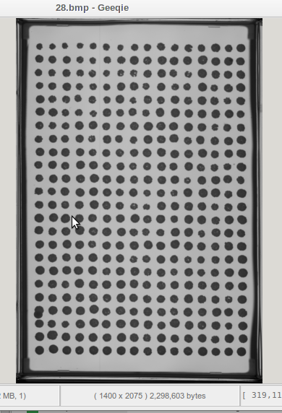
P1->

P13->

We will find a good image from another experiment.
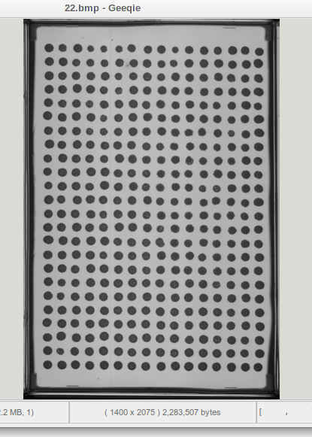

We now have some images to generate a composite centered map for EASY to search and find the nucleation area of each spot as it forms. Click the Run menu tab. A drop down list of options is presented. Click the first item → [Plate Map Pintool ].
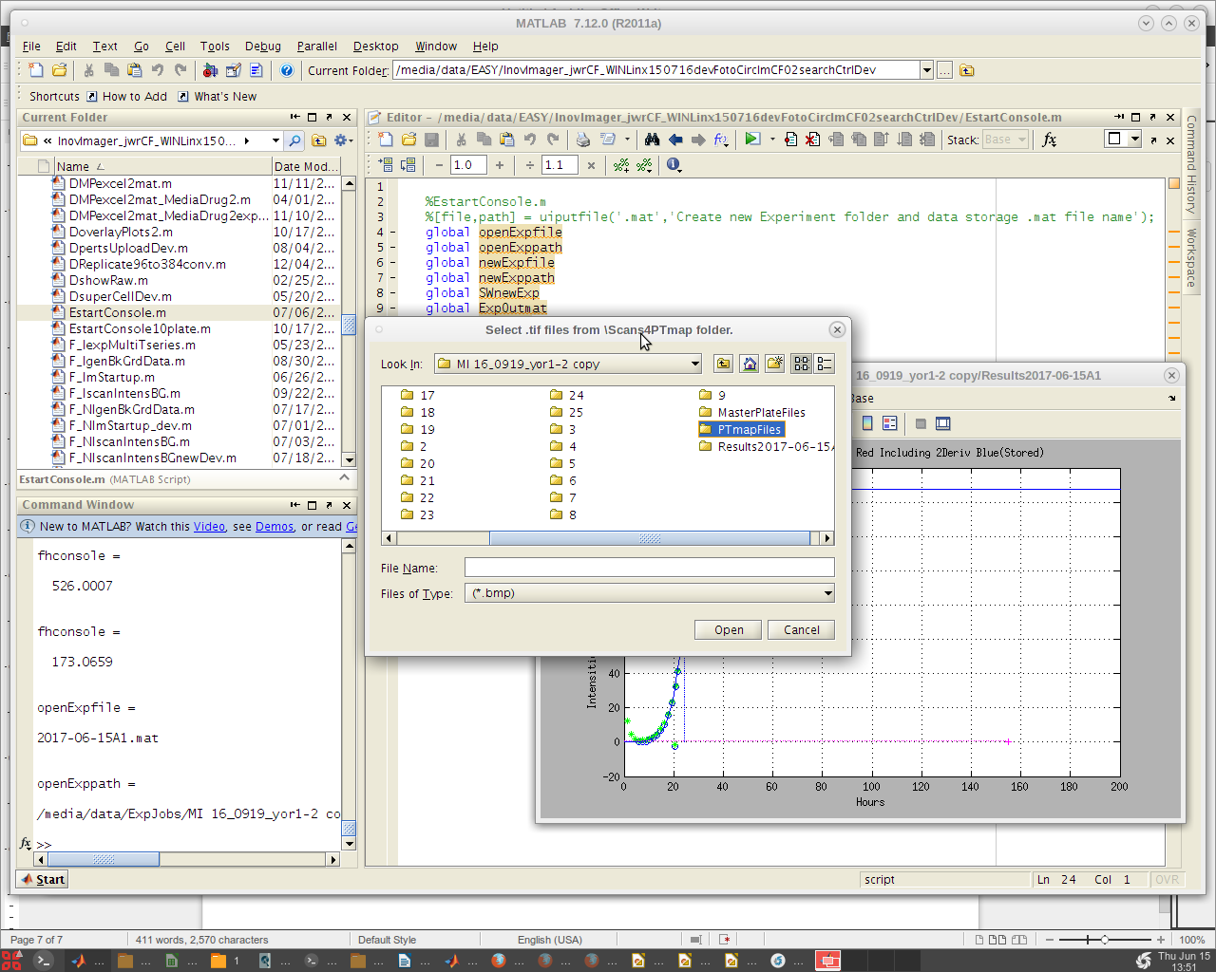
Open the PTmapFiles folder. Then click on the .bmp files you wish to include to make the pin tool map. Click the Open button.

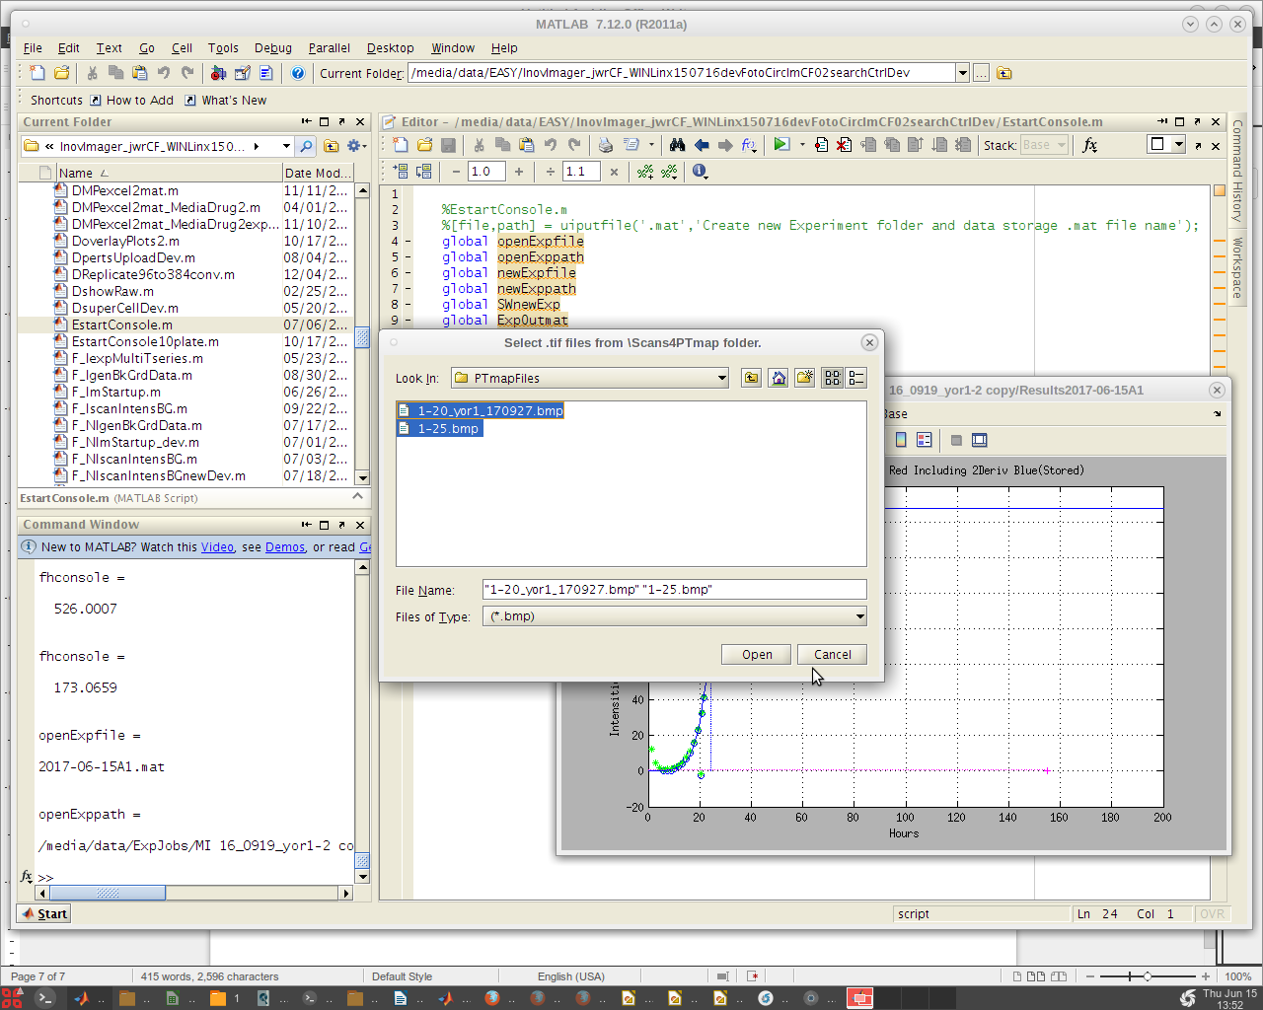
A warning dialog box may appear. This is nothing to be concerned about. Click OK and continue.
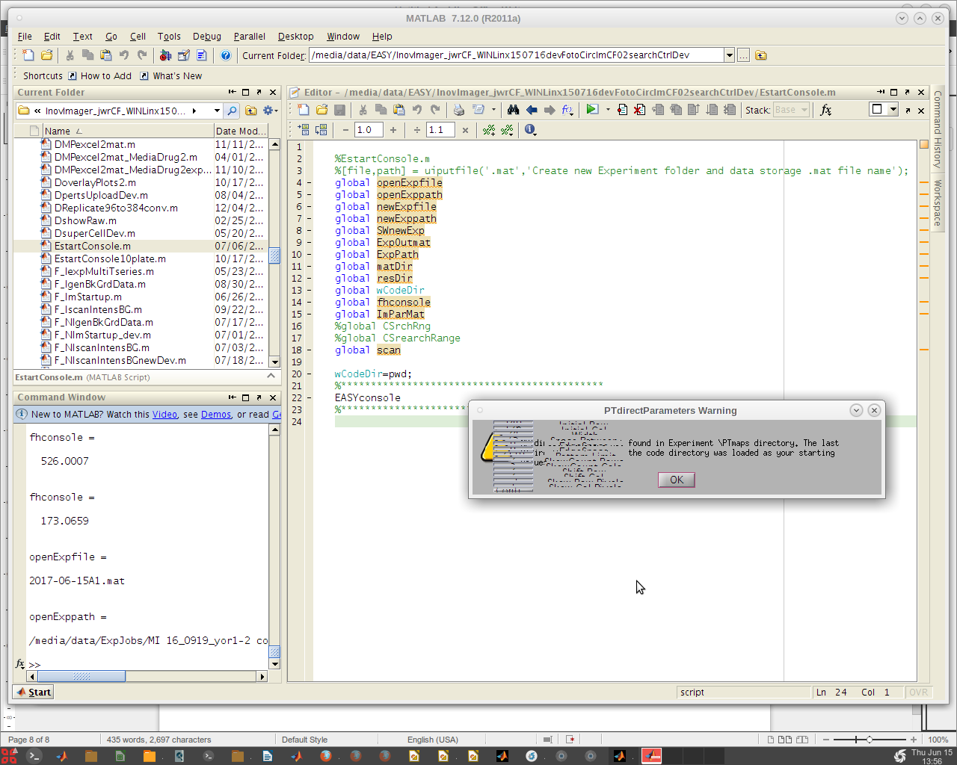
A view of the direct map from the current numeric values is presented. These values can be adjust if needed. Click 'Retry' to adjust them.
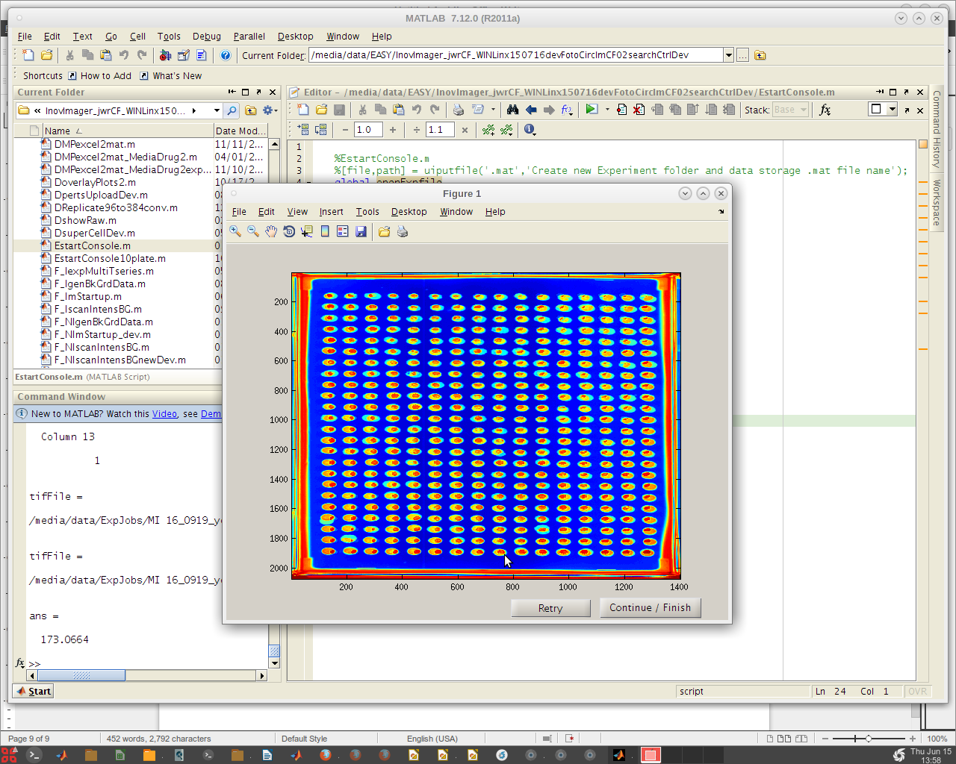
'Retry' takes you back so that to can select a different .bmp files from which to create the map from. In this case the spots from the two images are well aligned and give coverage to all the spots therefore we do not have to add new images. Remember, this map is just a good guess as to where to start looking for each spot not where it will focus to capture intensities.
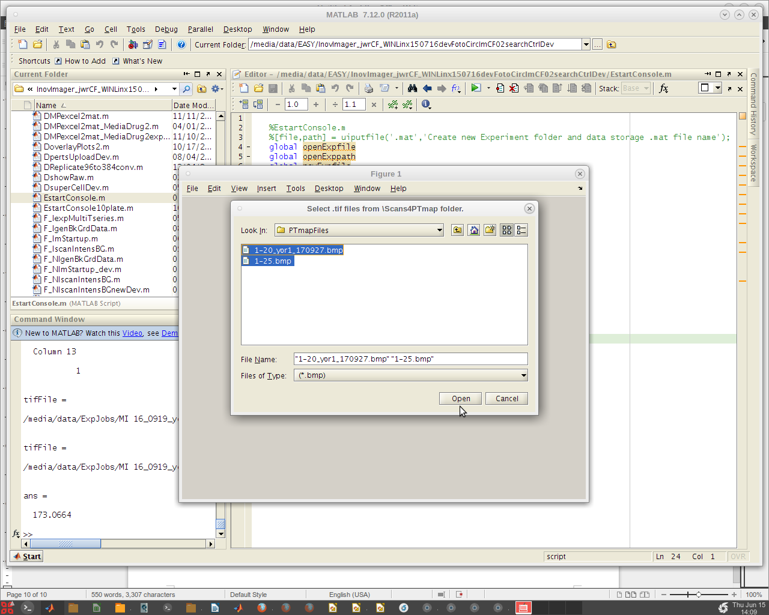
Click 'Open' again.
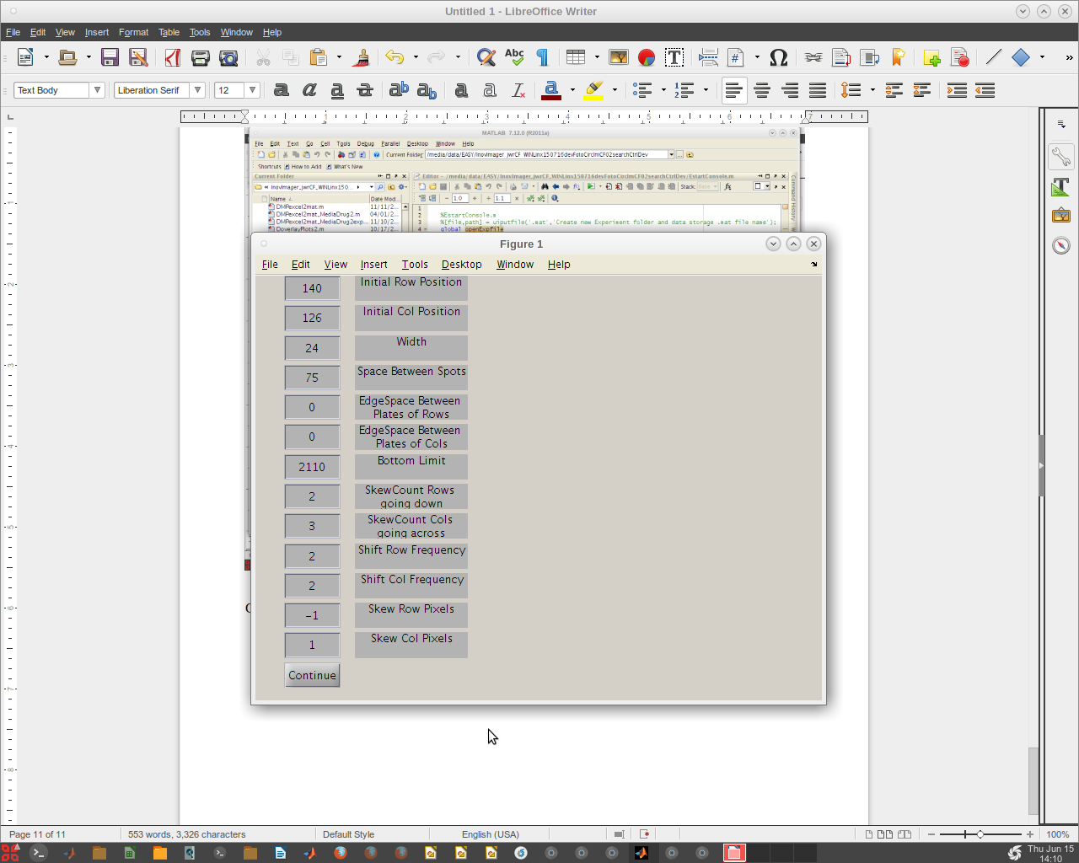
We can now shift these values to get a better 'hard' start for this search. Maybe we can move this search point to the left a bit by decreasing the 'Initial Col Position' slightly to 120 and clicking continue.
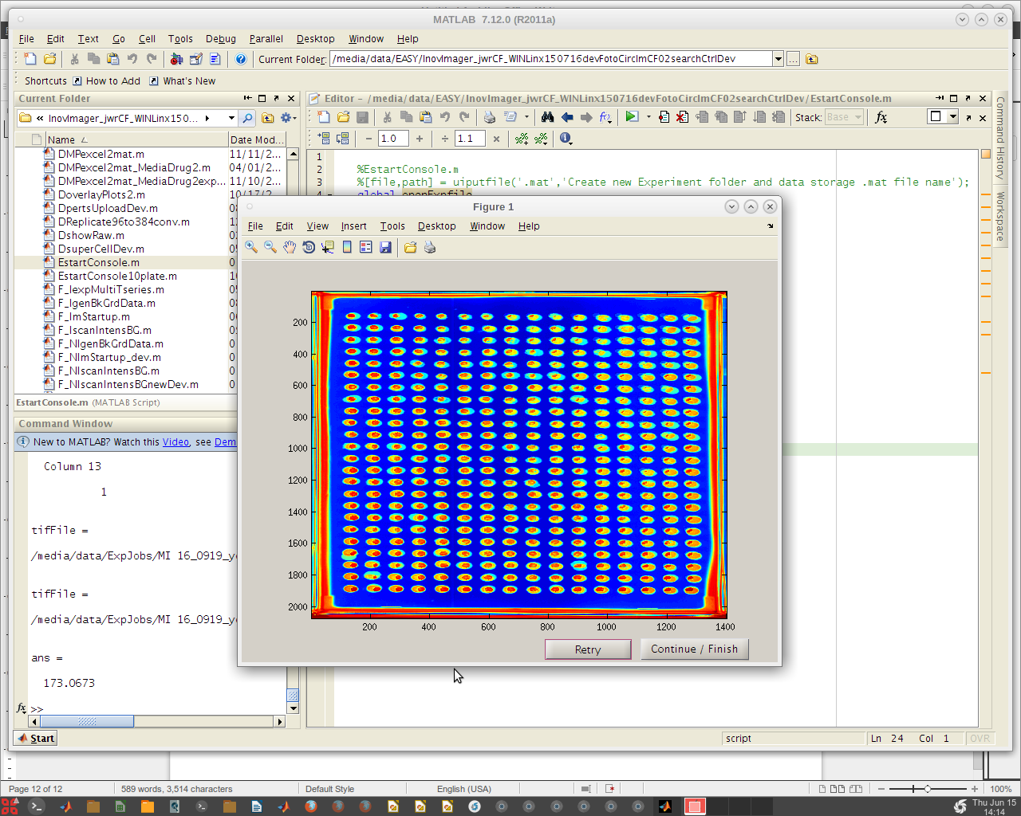
Even though the first result image using 126 may have given a good map, we will use the improve second initiation point by clicking the 'Continue/Finish' button.
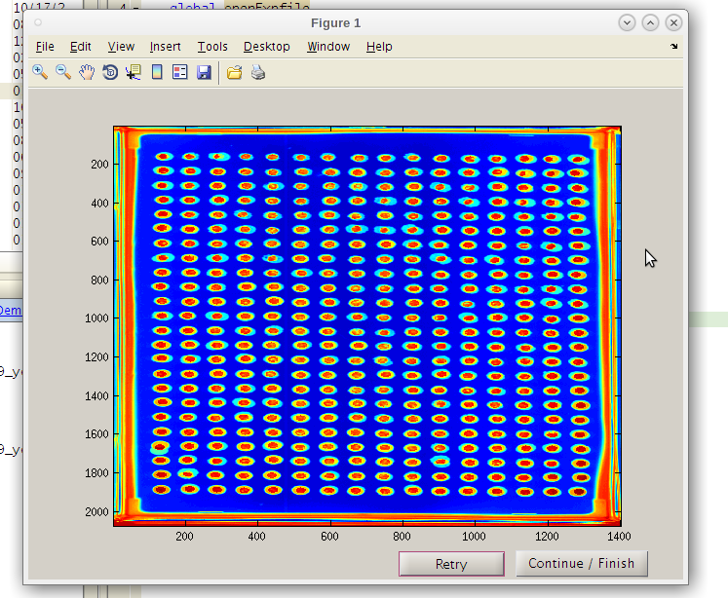

Note that the red “hot” spot is now well centered in each composite image spot. We can now click 'Continue / Finish' to proceed. The coordinates and parameters will be stored in the results folder 'PTmats'. This is where the .mat files which contain localization data for use in the next section of our work.
The EASY GUI will come back. Now click the 'Run' → 'Image Curve ComboAnalysi' . This will perform the image quantification and then generate the curve fits for each plate selected. Typically we pick only one plate at a time for one or two master plates. The software will present the final image of the search if only 1 master plate is selected. If multiple plates are selected, no search images will be presented or stored as figures. However all the position data for every spot at every time point will be stored. This large data trove is used by EZview to produce the image click-on hot spot maps and the photo strips.
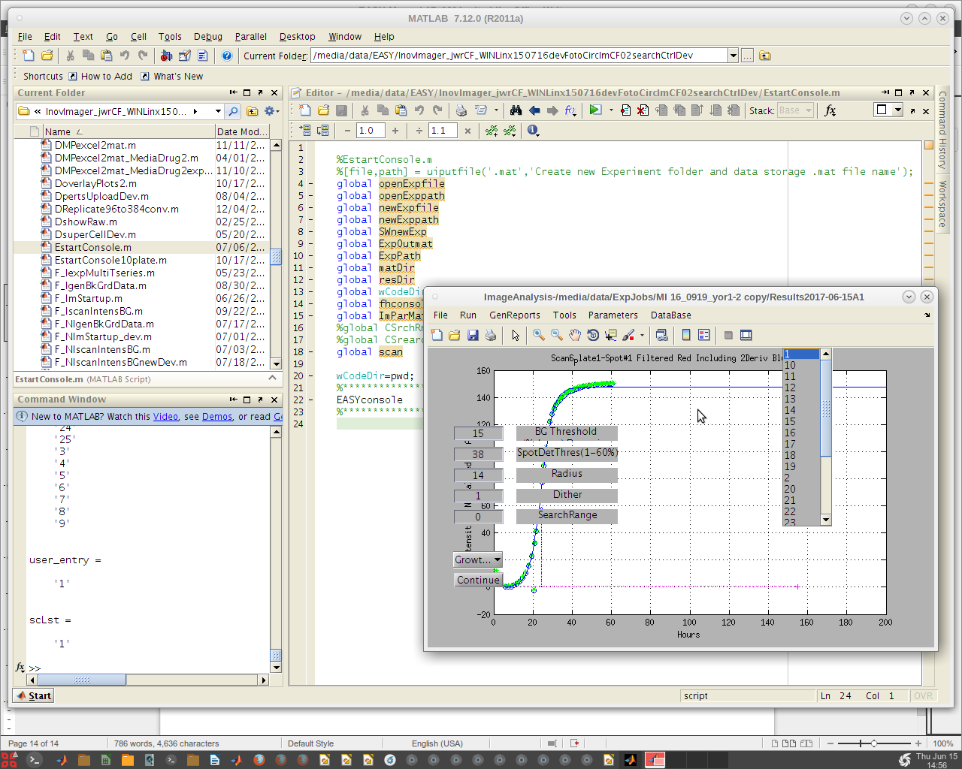
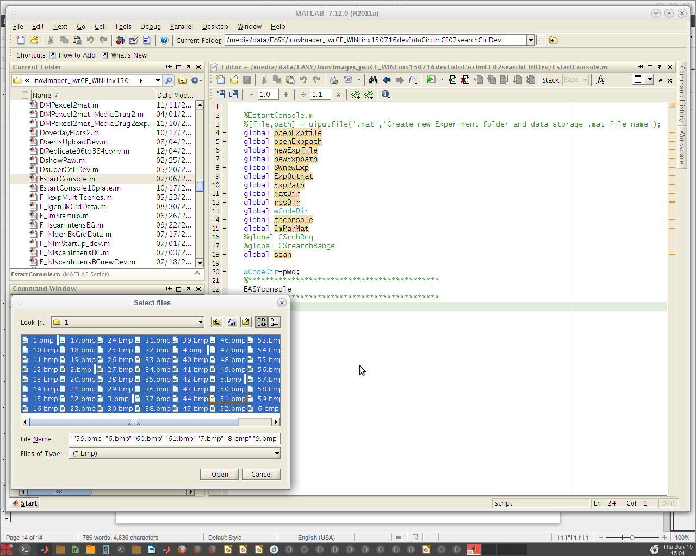
Note the 'Select Files' dialog. It allow the user to select the specific .bmp files to use. This can be useful if there are bad ones that need to be removed from the folder due to contamination. If all are good we can select them all and click 'Open' to run the process. There are other parameters that can be selected. For now we will continue and come back to those later.
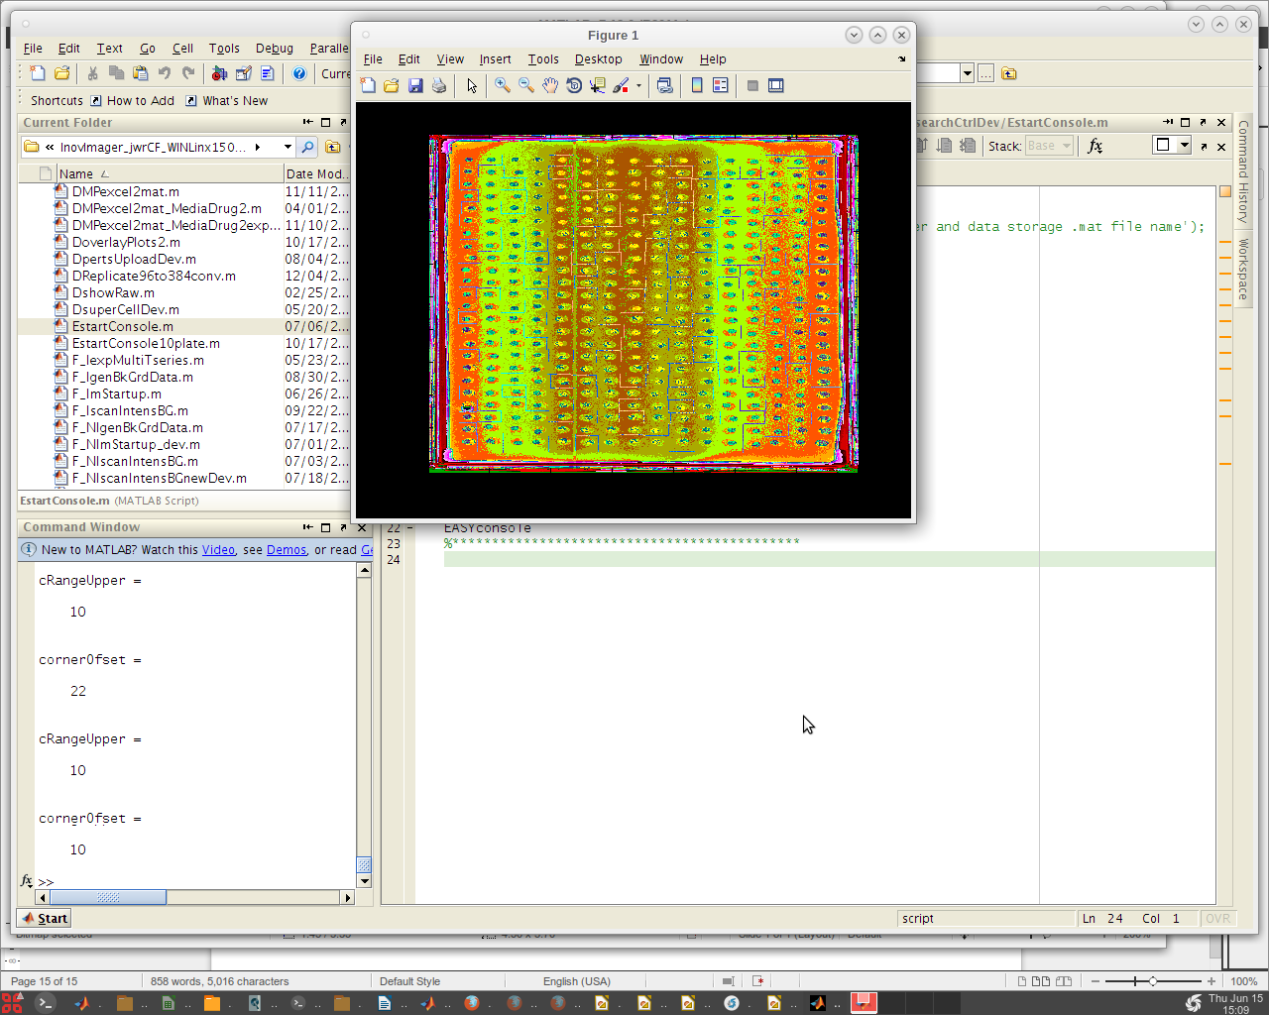

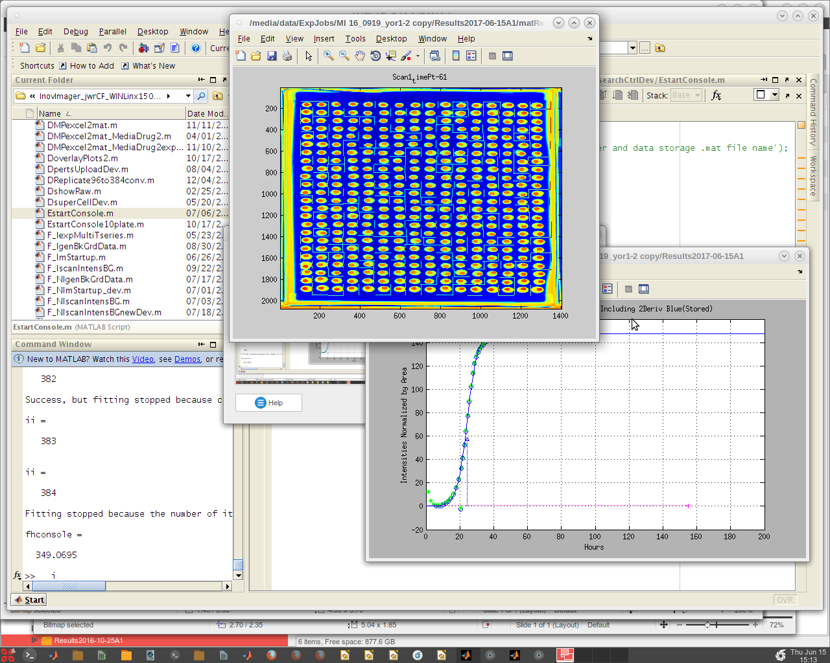
The search focus of each spot at the end of the run is presented for examination. Notice that these have floated and locked in to a position determined on the fly to a point where the initial growth has exceed has reach a point of maturity. This prevents a jump to a late onset jump to a contamination site . If we found that we need to adjust our pin tool map or make other modifications, we can do that and rerun these single runs until we are satisfied.
Next we will run the entire experiment by clicking on all the other master plates from the list box.
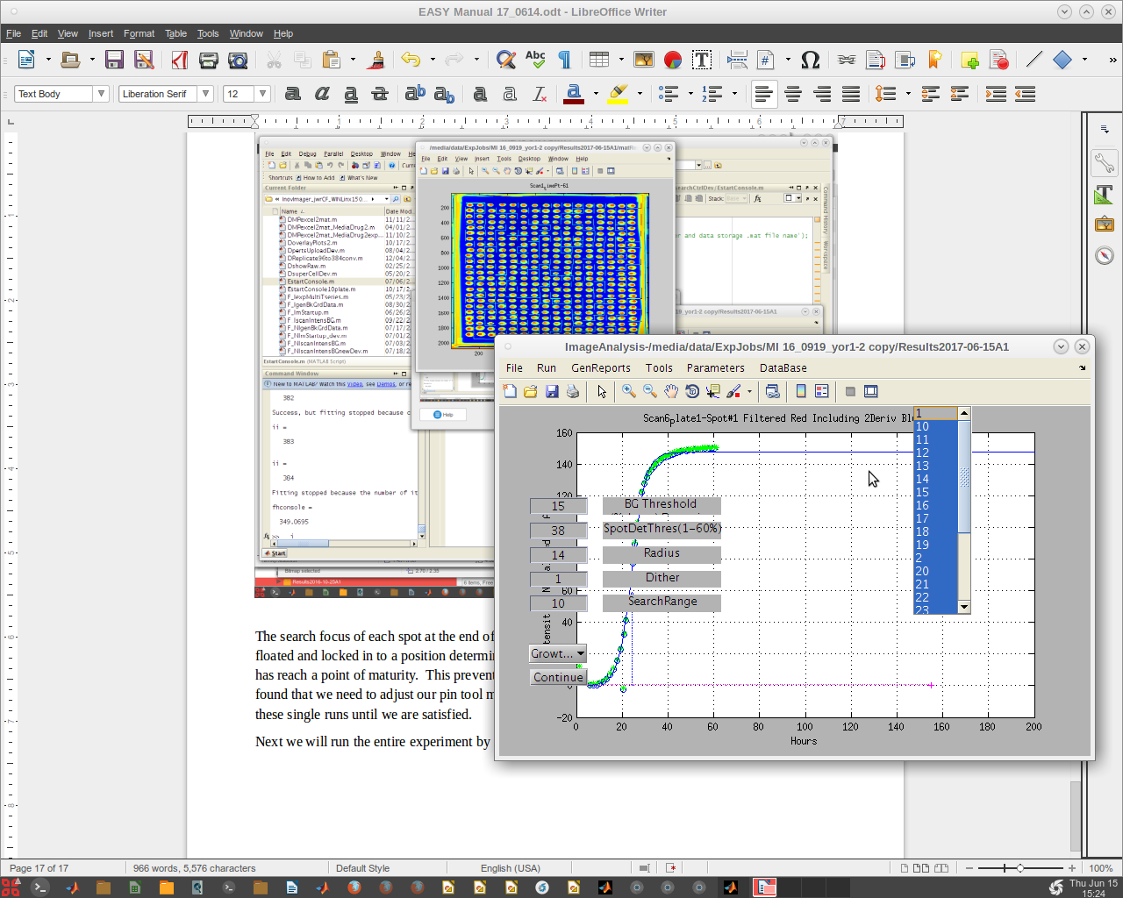
Depending on the number of master plates and the number of time point images taken for each, this next step can take a while. Click continue and do something else while the computer works.
When the work is complete the EASY GUI will reappear without the master plate list.
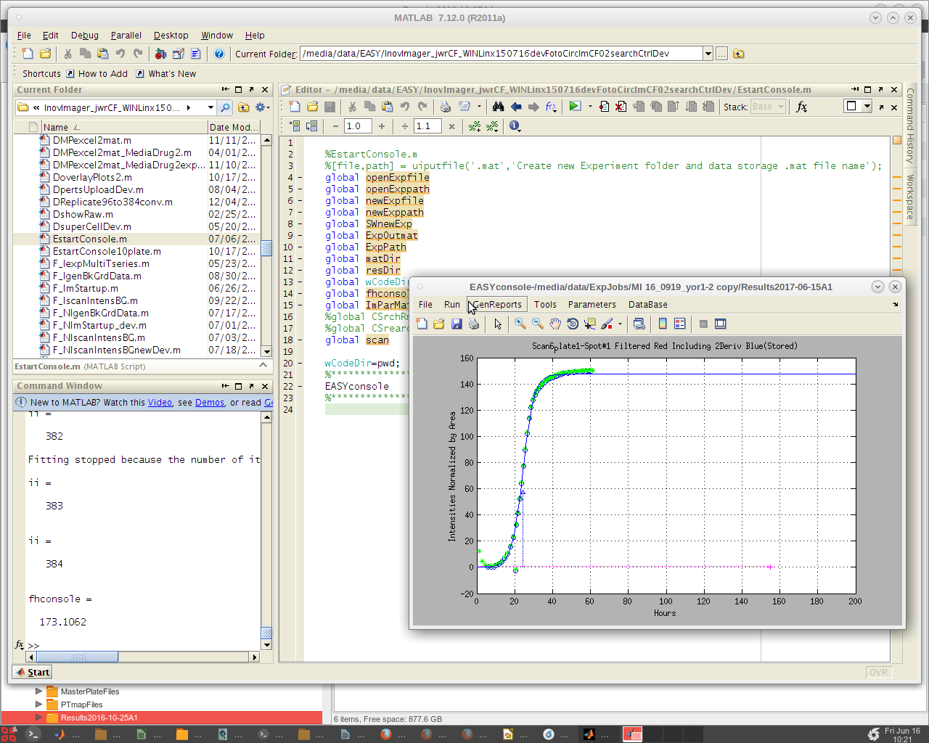
Now look in the /Results* /PrintResults folder to check that all the plates have run and produced data.
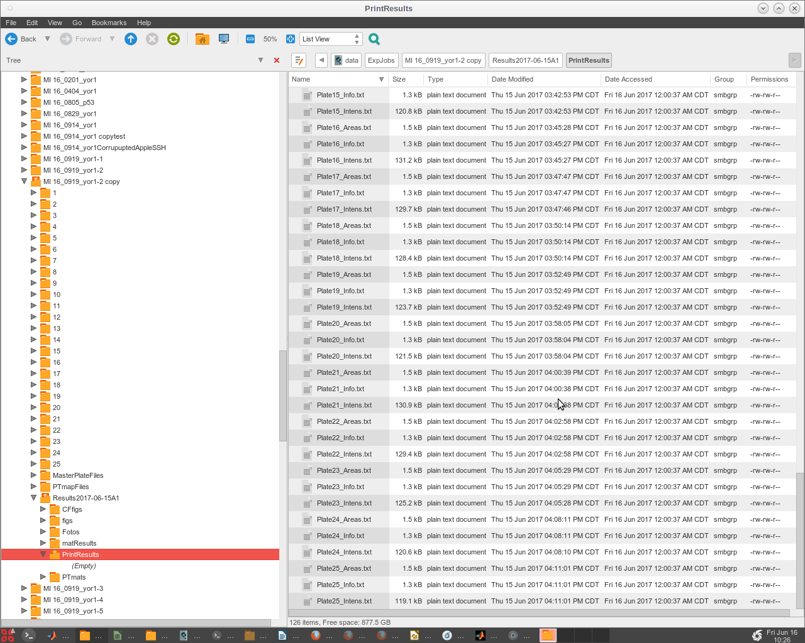
This is a legacy print copy of data, but is still useful to check that all the quantification was completed successfully.

Generate Reports
Generate a MPDM.mat file from the Excel master plate and drug media sheets that the user prepared as part of the experiment preparation. These sheets must conform to certain format rules. It is best when creating these to use a working copy as a template and replace the data with that of the current experiment. See Master Plate and Drug-Media Plate topic for details.
Click on the 'GenReports' menu tab and a drop down menu is presented the the first item 'DrugMediaMP Generate .mat'. This will take you to the /MasterPlateFiles folder within the experiment currently being analyzed. Do as the dialog box instructs. Select the Master Plate Excel file first.
Important note: These files (both for master plates and drug-medias) must be generated or converted to the Excel 95 version to be read in Linux. This can be done on either a Windows or an Apple machine running Excel.
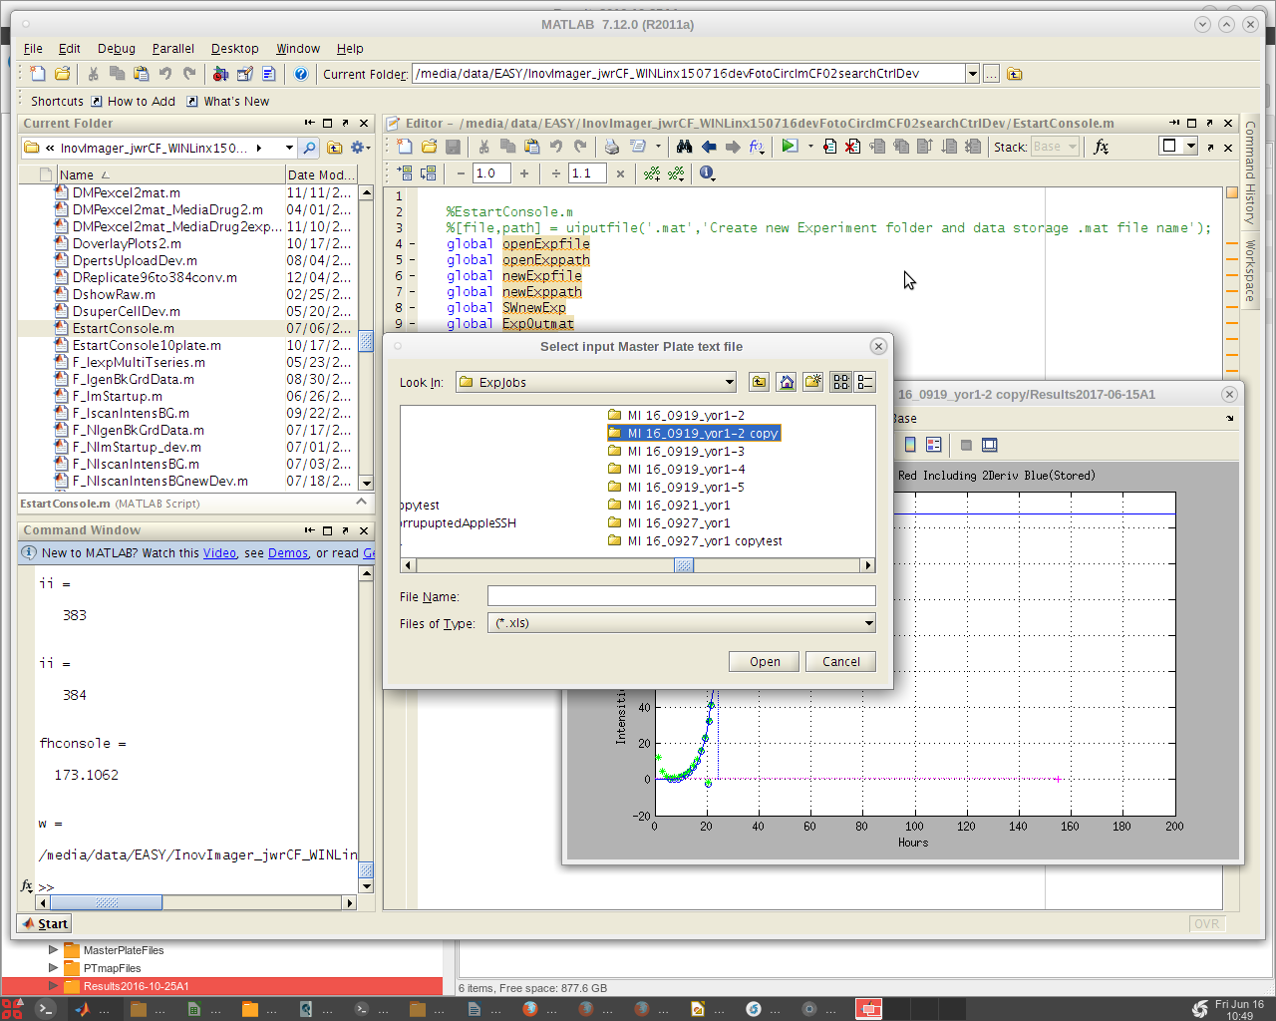
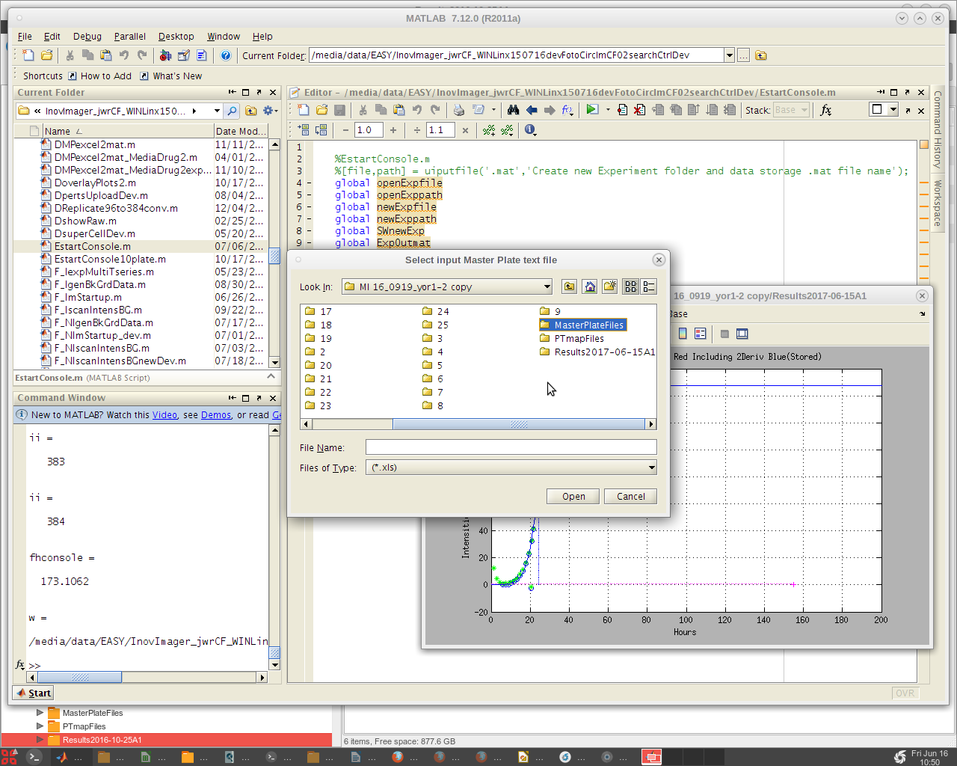
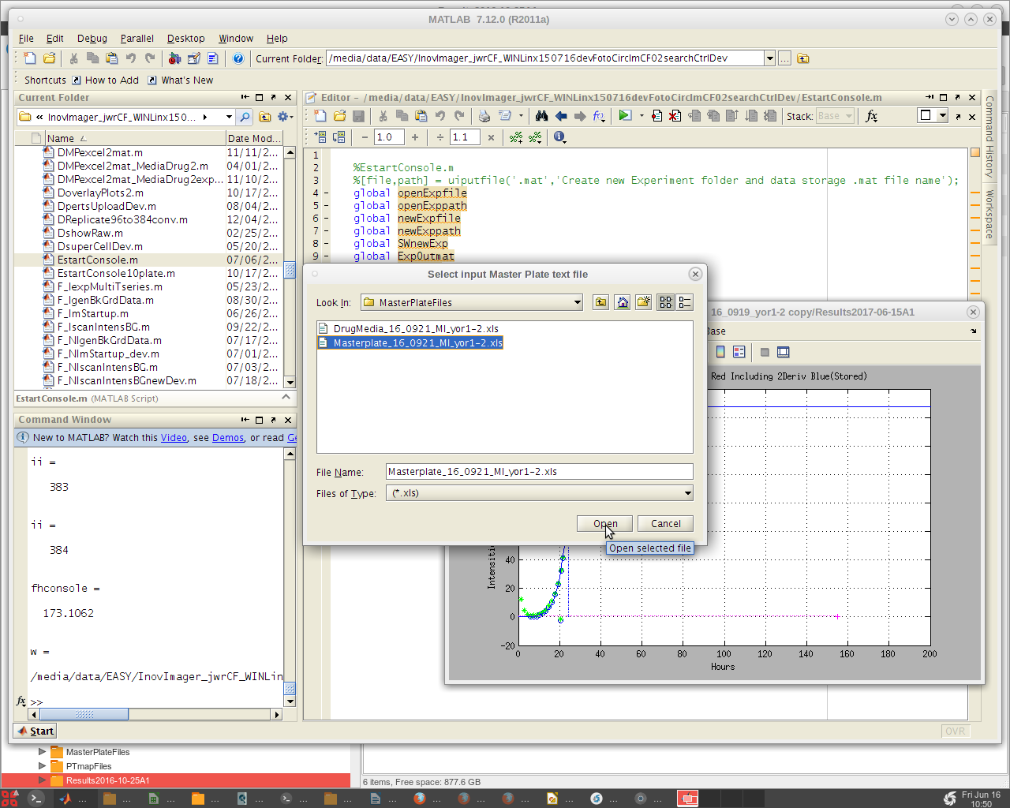
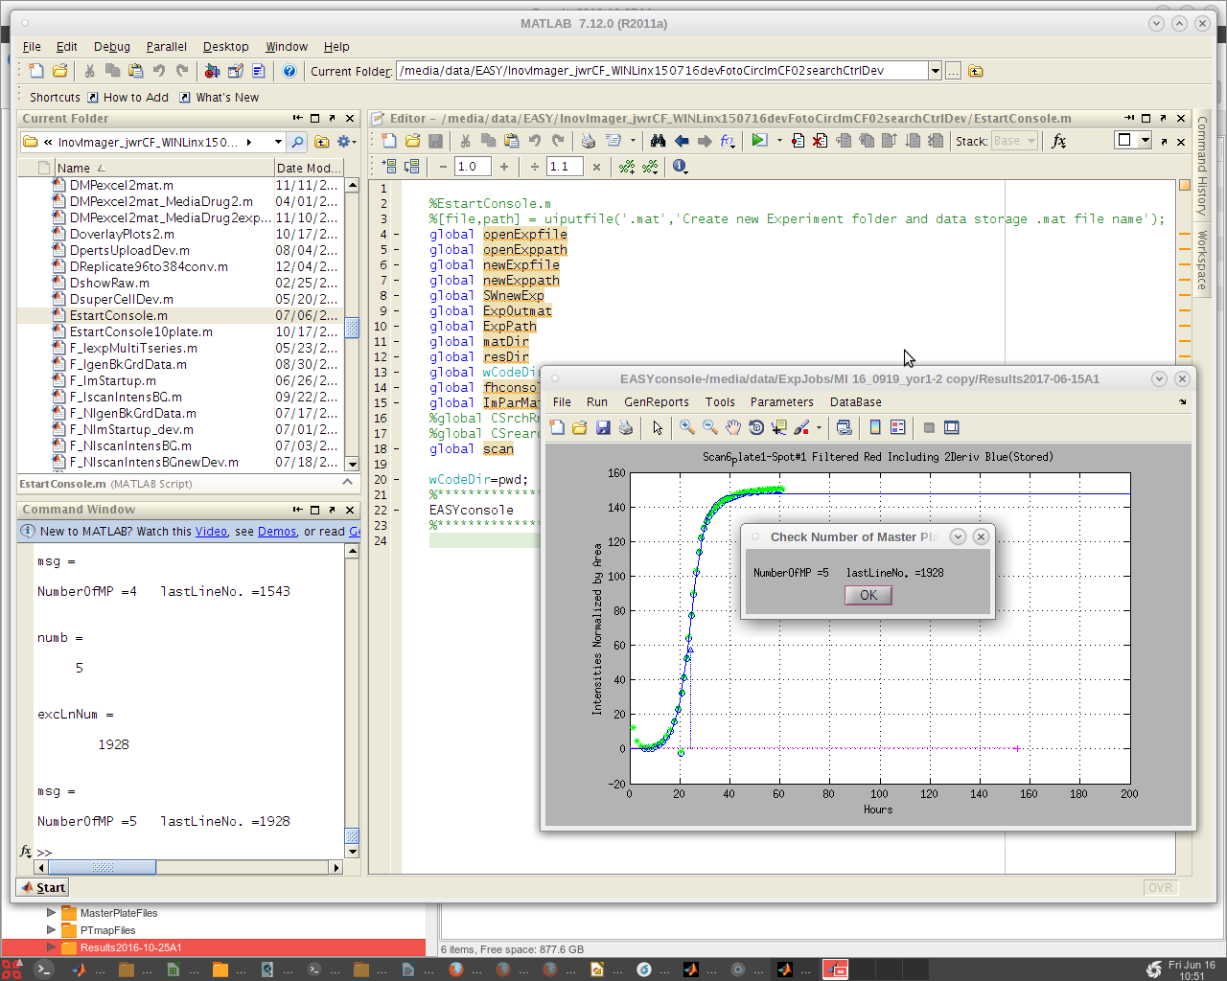
A message dialog pops up. Click 'OK'.
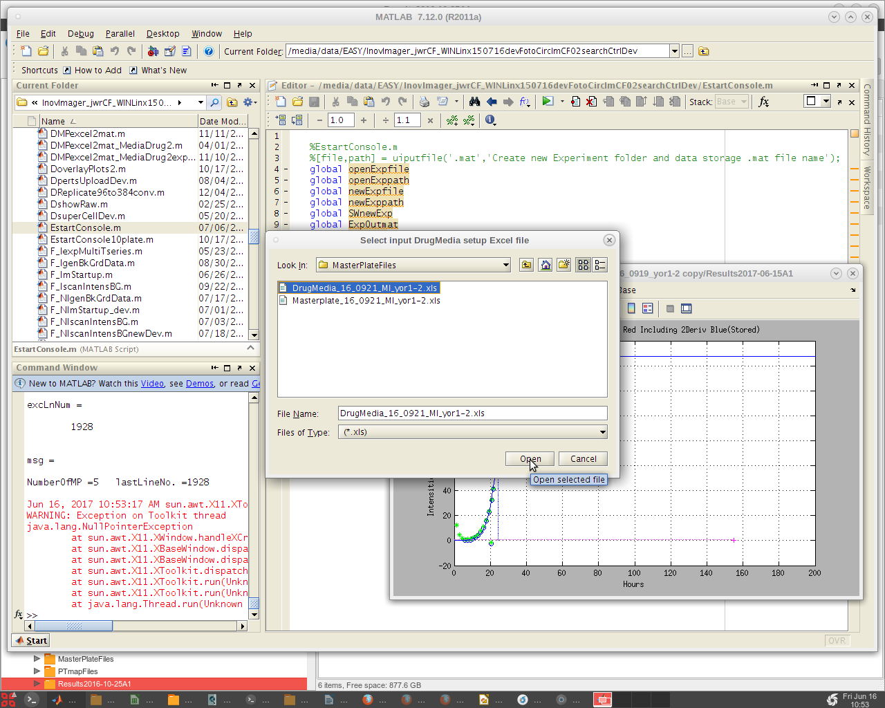
Next click on the 'GenReports' menu tab and the second item in the drop down list 'ResultsDB Generate'.
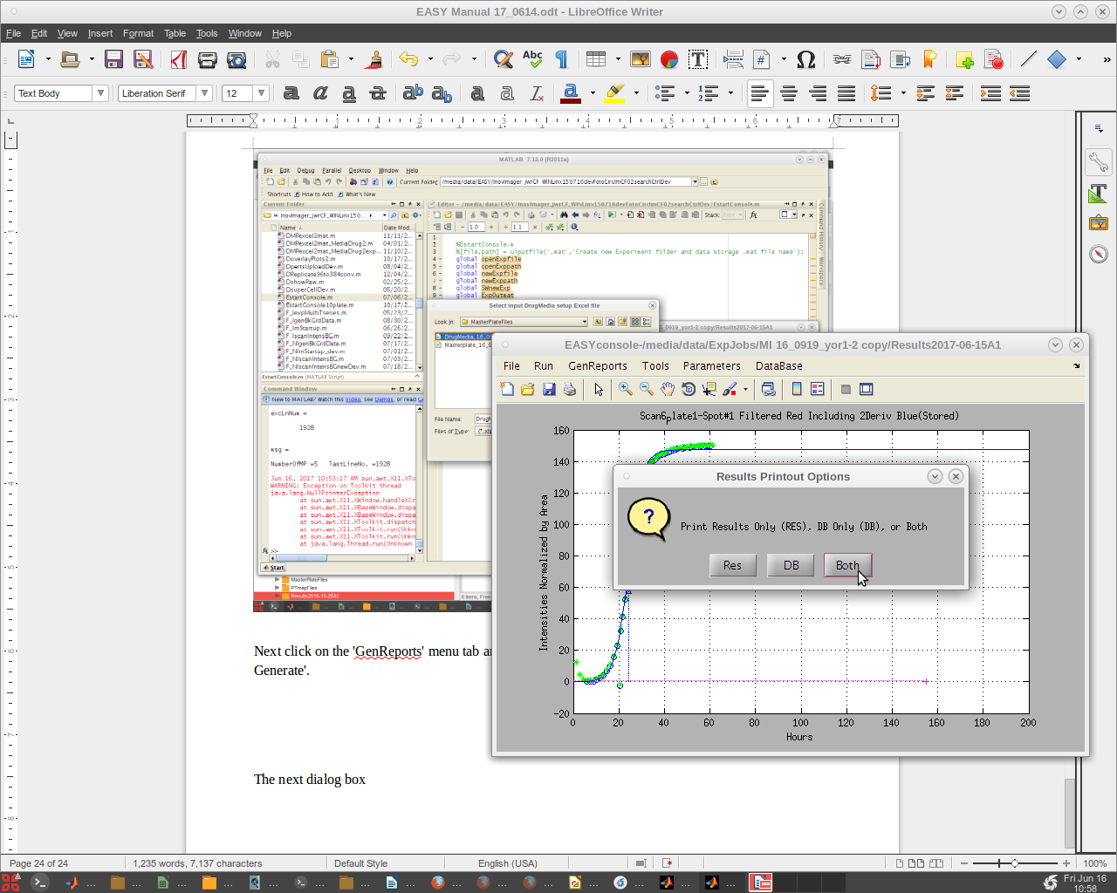
A dialog box with options appears. The default is 'Both'. 'Res' produces only a standard result sheet in the current experiments /Results*/PrintResults folder. 'DB' produces only a special file for convenient upload to databases. This file has no blank rows separating the plates and combines the raw data for each line item into a 'blob' as this is a convenient way to store data of variant lengths in a single database field. (The concatenation of data for each row take a while. But is useful for uploading data.) Typically 'Both' is the preferred option, however, if one needs to review the results quickly, this provides that option.

We can open the !!Results MI 16_0919 yor1-1 copy.txt text file using Libre Open Office to review the results.
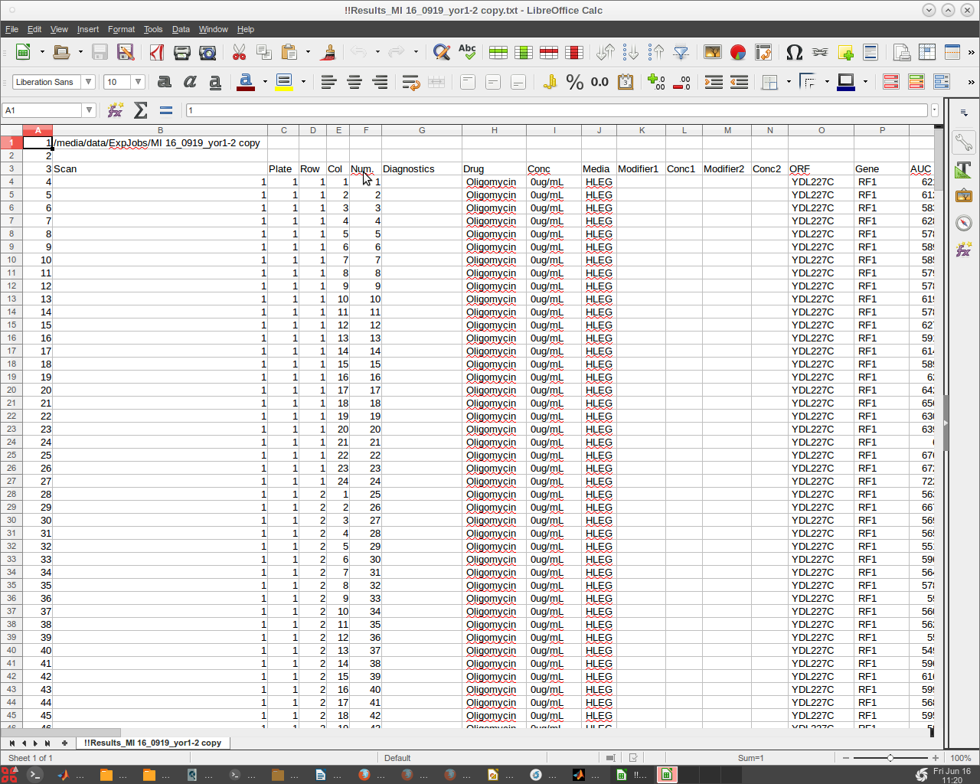
We can do likewise with the !!Dbase_MI 16_0919_yor1-2 copy.txt text file.
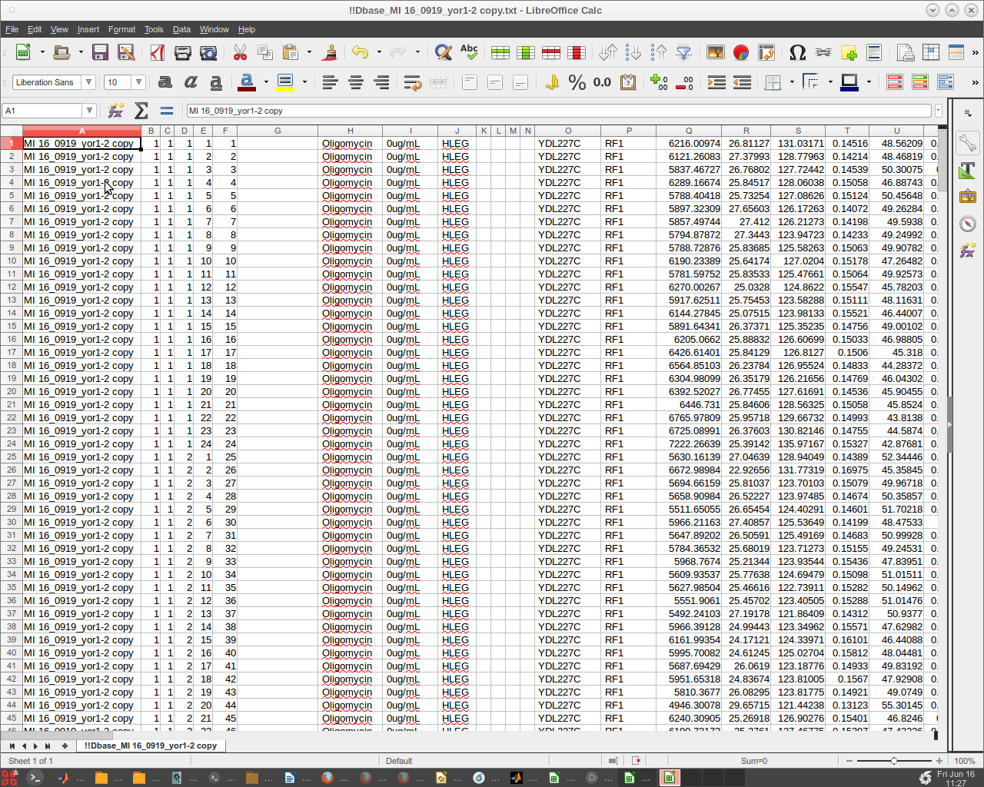
Note that there are no headers or empty rows. Since Libre may corrupt the text files, it could be advisable to only read them and refrain from any 'Save' options presented.

Master Plate and Drug-Media Spreadsheet
Excel spreadsheets provide a concise way to provide a great deal of information to our computational system. The Master Plate and Drug- Media Spreadsheets are prepared by the user to correlate the collected and calculated data with the defining definitions of the cultures, drugs and media involved in producing the experimental data. These spreadsheets have a very specific format which was instigated at the beginning of our work. To maintain compatibility over the years, we maintain that format.
To begin with, our system can be used with Windows, Linux and Apple operating systems. To accommodate these OS's, the Excel version must be an older Excel 95 version which is cross compatible for Matlab versions within all three major OS's. Windows is more tolerant, but to avoid problems producing results reports, ALWAYS use the Excel 95 format for your spreadsheets.
Do not remove any header rows. They can be modified with exception of the triple hash (###).
Do not change the number or order of the columns.
Next place a 'space' in unused empty spreadsheet entry positions. This can cause problems in general for some software utilities. It is just best to make this a standard practice. Avoid using special characters. Depending on the OS and software utility (especially database utilities), these can be problematic. Certain 'date' associated entries such as Oct1 or OCT1 will be interpreted by Excel as a date and automatically formatted as such. Do not use Oct1 (which is a yeast gene name) instead use Oct1_ or it's ORF name instead.
When creating a Master Plate spreadsheet, it is best to start with a working spreadsheet template and adjust it to your descriptive data. Be sure that ### mark is always present in the first column of the header for each plate. This is important convention as it is used to defined a new plate set of entry data.
Each plate is expected to have 384 rows of data correlated with the 384 wells of the source master plates. These have a particular order going through all 24 columns each row before proceeding to the next row. Gene names and ORF name entries should be as short as possible (4-5 character max if possible) as these are used repeatedly as part of concatenated descriptors. The 'Replicate' field and the 'Specifics' fields can be used for additional information. The 'Replicate' field was originally designed to allow the user to sort replicates but it can be used for other relevant information. The 'Specifics' field was created to handle special cases where the liquid media in which cultures were grown on a single source plate was selectively varied. This gives the researcher a way to sort by growth media as well as gene or ORF name. It can also be used to sort other properties instead of modifying the gene name field. Thoughtful experiment design and layout are important for the successful analysis of the resultant data.

It is typically a good idea to create at least one reference full plate and make that plate the first source master plate. Typically we give those reference cultures the 'Gene Name' RF1. Traditionally we also made a second full reference plate with its cultures labeled RF2. More recently some researchers have gone to dispersing RF1 control reference cultures throughout the source master plates series in addition to the first full source master plate. The EZview software has been updated accordingly to find these references and perform associated calculations.
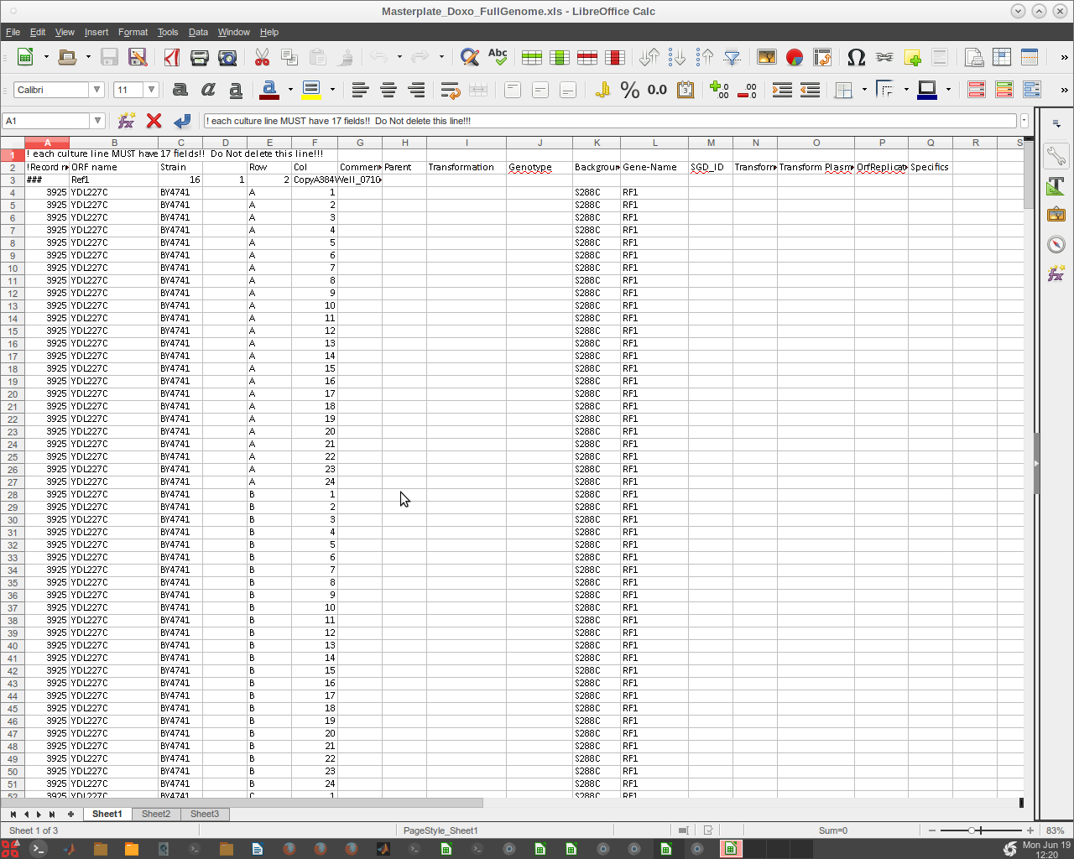
There are a number of fields on the spreadsheet which in this case were left empty. This spreadsheet format was created originally with studies of whole yeast genome SGA modifications incorporated. Therefore all fields may not be relevant. However, when ever relevant it is strongly advised to fill in all the appropriate data.
The Drug-Media spreadsheet defines the perturbation components of each type of agar plate that the source master plates are printed on. Again the format adherence is essential. There is a '1' in the first column- second row (A2). This has as legacy going back to early use. It is still necessary and should not be deleted. The header row must not be deleted.
A triple hash(###) must be placed in the cell below the last entry in the Drug field (Column 2). Again insert a 'space' in each unused or empty cell in each field. Again avoid special characters which may cause problems if not in the experiment quantification in subsequent analysis utilities. A utility looking for a text field may end up reading a null and respond inappropriately. As with the master plate Excel sheet, it is a good idea to use a working copy of an existing Drug-Media spreadsheet and adapt it to ones needs.



