Instruction for REMc and heatmap plotting
Version 2 by Jingyu Guo. 2013 Mar.
Before start everything, I want to say "Online search engines are your best teachers for dealing with computer questions."
1 REMc clustering
The current version of REMc clustering code is done in Java, utilizing Weka package (http://www.cs.waikato.ac.nz/ml/weka/). So the code can be run on any operation systems as long as it has the Java SE 1.6 (and up potentially) installed. When the option of real-time GOid_z calculation is not chosen, the code can run properly on a laptop/desktop with regular amount of data (up to a full yeast genomic list with 10-30 columns) in 10mins to 1 hour. Using Eclipse to run the code is recommended (other IDE environment is fine as well such as NetBeans) to make a nice GUI, but to run the code as a JAR file is applicable as long as Weka package is included. One can create JAR files from the source code in Eclipse.
1.1 Setup the environment
1.1.1 Install Eclipse
Eclipse is an excellent integrative development environment (IDE) for Java and other computer language projects. Most Eclipse Java IDE package will include Java Runtime Environment (JRE) such as Java SE 1.6 .
- Download Eclipse installation package from the official Eclipse website (http://www.eclipse.org/). Choose the suitable platform. The Classical package is sufficient for the purpose. Install the updated version. The current version is 4.2, whose development code is named 'Juno'.
- Follow the instruction for the installation (http://wiki.eclipse.org/Eclipse/Installation). In most cases, all you need to do to install Eclipse is to unzip the downloaded package into the right folder.
- Eclipse is a powerful tool. For more information regarding how to utilize and update Eclipse, please see http://help.eclipse.org/juno/index.jsp. Another nice guide for Java and Eclipse can be found here http://eclipsetutorial.sourceforge.net/totalbeginner.html. I highly recommend to go through the tutorial if you want to seriously learn a programming tool and Java the most classical object-oriented programming language.
1.1.2 Setup environment in Eclipse and load the weka package
An important concept in Eclipse (as well in a lot of IDEs) is working folder (workspace), which is a path/directory in the computer file system for Eclipse to store the coding projects. Working folder can be and is usually different from the installation folder of Eclipse. A Java project can contain many pieces of Java code, imported Java packages, parameter files and data files. In Eclipse, every element of a named Java project will be stored as a separated folder with the same name in the working folder in the file system.
- Launch Eclipse the first time, it will ask for the working folder setup. Create a dedicated folder as working folder in file system and input the path in the pop-up window when you start Eclipse the first time.
- In Eclipse, create a new Java project from the File tag. 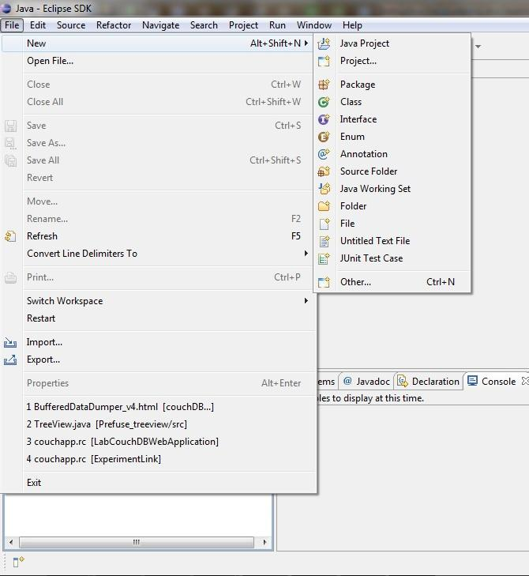

- In the pop-up window, type in the project name. Then choose the JRE, normally the defaulted choice is good (in this case, JavaSE-1.7). It is fine to leave every parameter as defaulted (most can be changed later). Click on Finish. Now check the working folder in the file system, a new folder named as the project name should be created in the working folder, along with subfolders created inside. Please notice one subfolder is named 'src' -- this is the folder to store Java source code; and another subfolder named 'lib' -- this is the folder for external Java library packages, in this case, Weka; and a third one named 'bin' -- this is for binary files that compiled from Java source code and other packages. The other input and output data and parameter files that involved in the code running can be stored in the project folder (together with these subfolders).
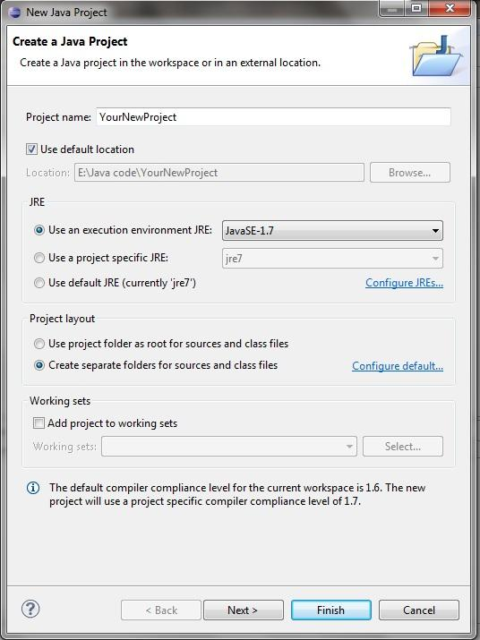

- Copy the code files into the 'src' folder. Here is a list of these files:
  - ExecMain.java
  - GetClusters.java
  - Information.java
  - Matrix.java
  - RawGoID.java
  - Stats.java

- Download the Weka package for Linux platform (.zip file) regardless of what platform the computer is using, from http://www.cs.waikato.ac.nz/ml/weka/index.html. Unzip the package (both Windows and Mac can unzip .zip file without additional software). Find a file in the unzipped folder named 'weka.jar' and move the file into the 'lib' subfolder of the Eclipse project folder.

The reason to use a Linux version of Weka is that now Weka release their packages by different installation suites for Mac, Windows and Linux. Only the Linux package can be dissected (since it is released as a compressed .zip file) and we only use the one component named 'weka.jar'. Since Java has a nice compatibility on every platform so we can still use a package for Linux without issues. (Note: Java code actually runs on Java Virture Machine (JVM), which is installed with the JRE. So only the JRE selects the platform or operation system but not the code runs on.)
- Now go back to the Eclipse window. In the left Navigation panel, right click on the project name you just created and select the ''Properties" in the pulled-up menu.

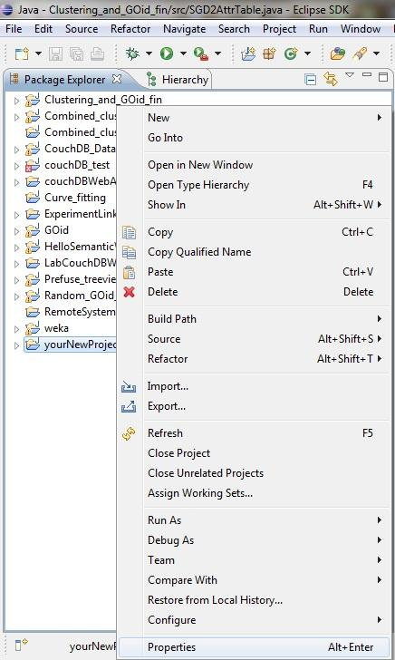

- In the 'Properties' console, select 'Java Build Path' on the left panel. Then choose the 'Libraries' tag on the middle-right panel as shown in the picture. On the right side of the console, click on the 'Add External JARs' and select the 'weka.jar' file just lefted in the 'lib' subfolder. Then the weka.jar will show up in the 'Libraries' list. Click 'OK' to turn off the 'Properties' console.
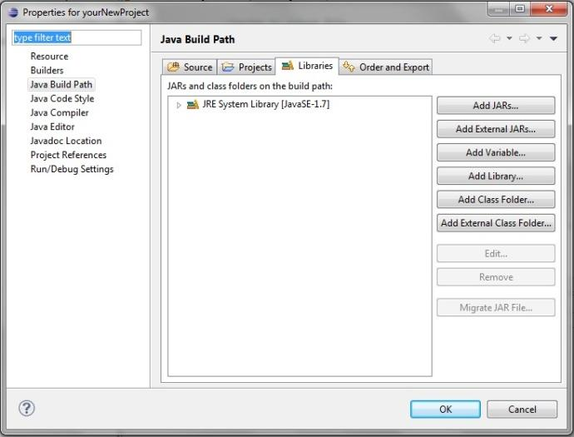

- Right click on the project name in the Navigation panel of Eclipse again and choose 'refresh'. Now you can navigate the source code files and the Weka package just imported into the project in the Navigation panel.
1.1.3 Run the code
To run the code, you need: 1) the Java code and required external packages, which was placed in the previous step; 2) the JRE, which was installed along with Eclipse; 3) data files, parameter and parameter files, which we will address in this step. In this section, I will go through the format of the data files and parameter files, where to place them and how to run the clustering code in eclipse.
- Data file: The REMc algorithm takes a single file of comma delimited data table (.csv file) or .arff format file (for details regarding ARFF file, please refer http://www.cs.waikato.ac.nz/ml/weka/arff.html. ARFF is specific to Weka and not commonly used elsewhere.) I recommend using .csv file, which can be easily exported from any Excel spreadsheet. The Data file has a few strict format requirements:
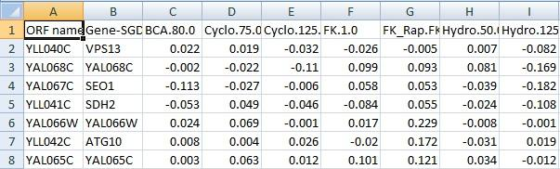
- Two columns of gene identifiers/labels, with the first column as the ORF name, and the second column as gene name (some ORF without gene names should be filled with ORF names but not left blank);
- One header row as the first row. The headers can be any letter/number string without ',' (comma) inside. Dot '.' is acceptable;
- Then, numbers should be filled in the attributes columns. No blank should be left. In case of a missing value, use '0' or other proper number that make sense statistically or biologically to replace. No digits restriction for each number but no need more than 8 digits. No restriction on number of attributes/columns but for the purpose of clustering, too many attributes introduce noise -- 10 to 30 should be OK. In case of more attributes, use PCA analysis first to reduce some attributes.
- FINALLY, PLEASE CLEAN CSV DATA BEFORE LOADING. By clean, I mean replace any unexpected characters/letters, ESPECIALLY REPLACE ALL COMMAS WITHIN FIELDS IN EXCEL SPREADSHEET before exporting to csv file. Think about this -- csv file is comma delimited format between fields, and if extra comma is in the data, it will create new field/column that the clustering code cannot process.
- This may not be that important. You want to name your csv file a nice detailed name so that you can distinguish files especially when you end up have hundreds data files eventually.
The data file should be placed in the Eclipse project folder, in parallel with the subfolders. Actually, other parameter files should be placed here. The output files will be written by the programs here as well.
- Parameter files: Two parameter files is required in the clustering and GOid_z calculation: 1) a scoring matrix table created from Gene Ontology information downloaded from SGD, GeneByGOAttributeMatrix_nofiltering.tab; 2) a background gene list containing all ORFs in the genomic library for raw GOid calculation, ORFs_pool.txt (so when the YGDS library is updated, the list should be updated). These two files are created by other code and will be discussed in later sections. As mentioned above, these two files should also be placed in the Eclipse project folder.
- Run the code in Eclipse:
  - configure the run: In the Eclipse menu, select "Run" and then click on "Run Configurations...". Then the Run Configuration window would pop up. In this window, one can configure the run environment and parameters for any project in Eclipse. So to configure the correct project to run, one need to locate the Main class for the Java project (Main class is the "start running point" for any Java project, other components in a Java project can be loaded from Main class in one way or another -- this is some knowledge important about Java) -- on the left panel, select the correct Main class file (the file containing Main class), in this case the file is named "ExecMain".
  - Then, click on the tab named "Arguments", and add the following 5 parameters in the "Program Arguments" textbox as shown in the picture:
1, data file for clustering; 2, lookup table file; 3, genome background file; 4, repeat counts (an integer) for real time random GOid calculation, only valid when the fifth parameter set to "false"; 5, Option to calculate GOid from function of regression analysis (boolean -- true or false), choose "true" normally to allow the from function calculation for less computation task.
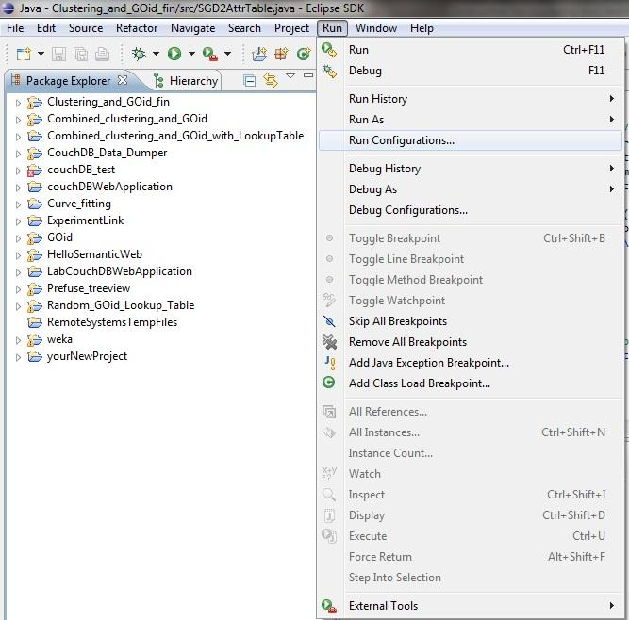
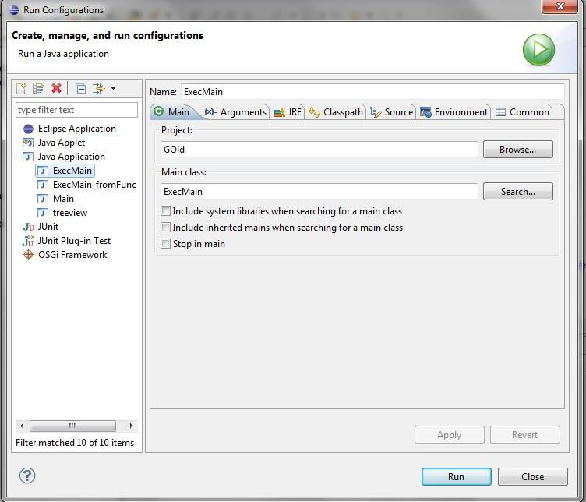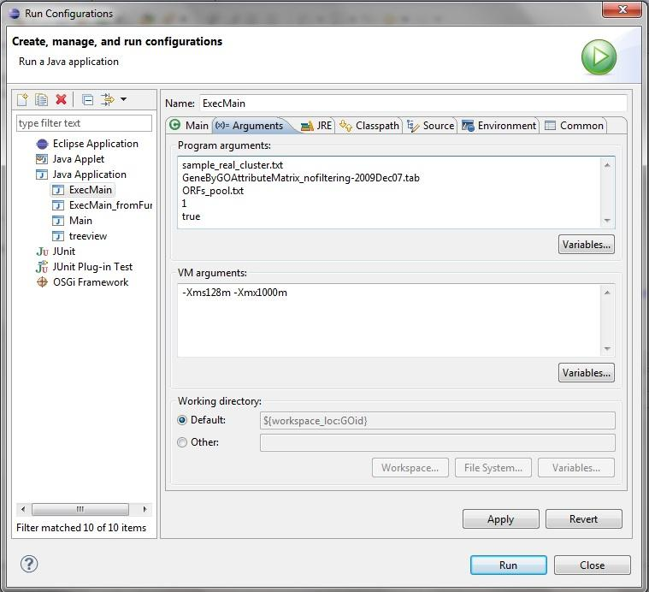

  - In the "VM arguments" textbox, type in the arguments for memory assignment permits, e.g. :
-Xms128m -Xmx1000m
Here, two arguments are pointed. The first "-Xms128m" argument indicates the minimum memory usage allowed, which is 128M in this case; The second "-Xmx1000m" argument indicates the minimum memory usage allowed, which is 1000M in this case. Minimum memory is a bottom limit to guarantee the program running complete. In this case, it is sufficient for a data table with 15 columns and 4000 rows. It can be increased to a higher value but not over maximum limit. Maximum memory is to restrict the allocation of memory to prevent the system getting crashed by running the code, normally it should not surpass half of the system memory.
  - After type in the arguments, click on the "Apply" button and close the window.
  - To run the code, select the "Run" menu and click on "Run". It can also be run from the button (green colored, looks like a 'play' button) on the Eclipse window panel.
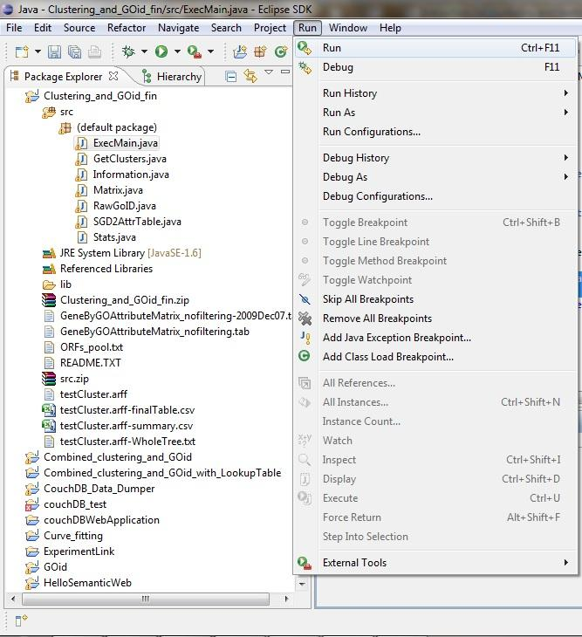
- During the running, check any error message in the Eclipse "console" on the right bottom of the Eclipse window. Other than the error thrown out by the program, memory outflow is another typical error.
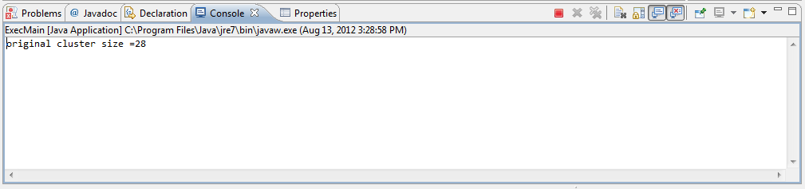

A sample looking is shown above. Some running information may be shown here (not necessarily error information). A stop button (small red block) on the header is given to terminate the running. Error information will be highlighted in different color than black (orange or red) with "Exception" notice. The example here is an error of insufficient memory (shown as "OutOfMeoryError: Java heap space").
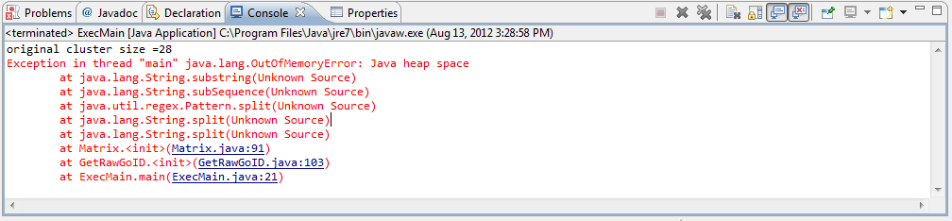

- After the running, the console would stop, as indicated by the inactivated stop botton (red block turns grey and not selectable), no error information shown in the console panel and "finished" notice shown in the panel (this is just for this program not necessarily for any Java program).
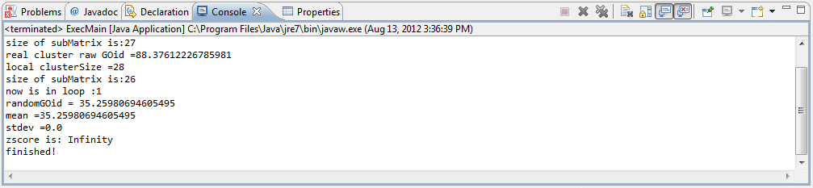

Now, in the project folder (still remember where it is, right?), one can expect to locate a few result files named with the data file name appended by following suffix:
"-WholeTree.txt";
"-finalTable.csv";
"-summary.csv";
" -tree.xml ";
".arff";

In those files, ".arff" file is automatic generated by weka package, which contained the input data file but in ARFF format (remember that we give a csv comma delimited data file to the program to run). "-tree.xml" is an xml data file (together with heatmaps) for plotting the tree view hierarchy with the "Prefuse" tree view program, which will be discussed in another section. The other three files are records for the REMc and GOid_z and can be parsed for heatmap plotting or other usage, which would be discussed in other sections.

Note: the REMc program can be achieved in a JAR file and run on a cluster computer and will be discussed in a separate section.

2 Heatmap plotting with python and Matlab
After the clustering file is done, one need to parse the result data to a set of clusters files that containing the data for plotting heatmaps. Then, these data files can be fed into the heatmap plotting Matlab code. To parse the data to a set of cluster files, as well as a set of cluster gene lists, one need to install python interpreter to run the python code of current development.
2.1 Setup Python coding and running environment
************************************************
(The following instruction is from Jingyu's lecturing of "Think Stats" to help setup python coding and running environment on a computer.)
1, Get the platform setup:
For *nix system:
a, Python Installation: unlikely needed. Most *nix kernel requires python to run properly. So to check the python installation, open up the “Terminal” and type in 'python' at prompt, then return. This will lead to the python interactive shell with python version info displayed.
b, text editor: where you can code and debug python program. I would recommend Emacs, Gedit or Vi for *nix user -- technically, any text editor would be fine for the purpose (text editor not Microsoft Word), but these editor may have a python friendly interface, in which the formatting and debugging would be much easier (especially as python is a language which takes indentation as the program structure) .
c, In Linux and Unix (maybe Mac as well, not sure still), typically use the following line as the first row in your python script. The path can be replaced by the path of python interpreter on your system:

#!/usr/bin/env python

For windows system:
Windows is not as programmer friendly as *nix systems. So there are a few things need to be setup in Windows:
a, python installation: for windows, it is easier to install the python by using ActivePython Community package. It is maintained and distributed by a third party (ActiveState) than Python Community itself. http://www.activestate.com/activepython Download the free community ActivePython package (msi package) and install it as any other windows software. To run the python shell, just find the ActivePython package from the program menu, choose Python interactive shell or Python GUI.
b, text editor: I recommend Gedit http://projects.gnome.org/gedit/ or Notepad++ http://notepad-plus-plus.org/ (which I like a lot). Again, it is a personal choice. The installation would be like any other windows software.
c, For running python in Windows, a few setup is required (also refer to http://www.imladris.com/Scripts/PythonForWindows.html ).
- Help Windows find python.exe (Yes, "Windows" is slow on this.)

- Setup the environment path for python to find your script.
Edit Windows
- We can hold on to the first two points and get back to this one later -- Make your code working in both Windows and *nix. -- For now, if you are going to run the code in Windows, always use the following line as the first row in your python script (You can replace the directory here by your python path.) :

#!c:/Python/python.exe

or in unbuffered mode like used in Apache setup (which is not going to be covered in this learning, so stick to the above line in your code.)

#!c:/Python/python.exe -u

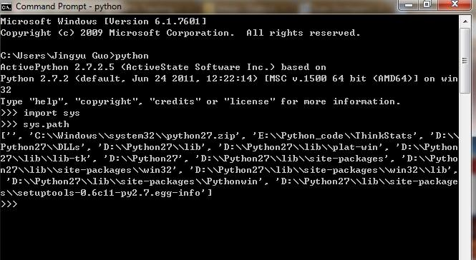

Fig. Check environment path for python interpreter. These are the directories that python will look up when search for imported libraries/modules/scripts.

A few points for Python:

Python is an example of a high-level language; other high-level languages you might have heard of are C, C++, Perl, and Java. Python is also a general-purpose, interpreted programming language whose design philosophy emphasizes code readability. Its syntax is clear and expressive, and a lot like natural English.

Compare Intepreted language vs Compile language. Python use the interpreter so does not require compile so it is flatform dependent and relatively slow (someone considered it as drawback) . On the other hand, using interpreter would allow interactive shell that facilitate trial programming with python. So a lot of large project can be done in python before converted to C++ or Java. In my opinion, python is well suitable for scientific computation as 1) scientific computing was in a sort of 'perpetual development' status; 2) python is designed for script processing (string/number processing), which is widely existing in scientific computing; 3) out of all programming languages, python is learned by one of the largest community (may be second to C++ and Java) and has a large and comprehensive standard library, which can be learned and used in your own python code.

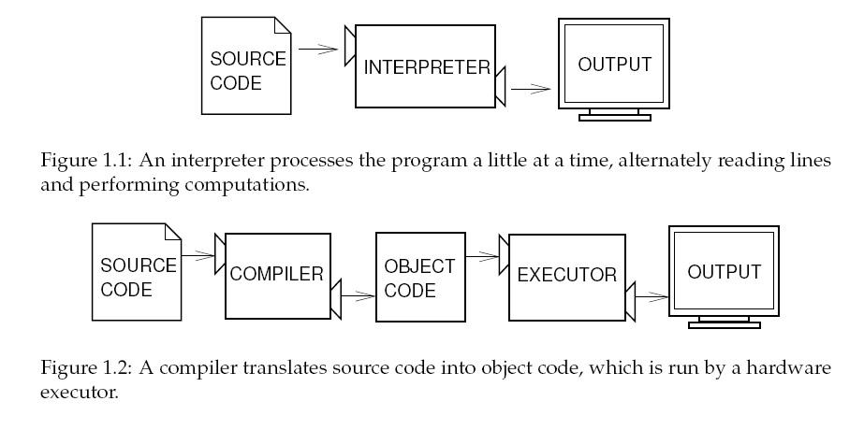
Fig. interpreted language v.s. compiled language (Figure above from ThinkPython, by Allen Downey)

The python version we will use would be python 2.7 or slightly elder ones. I do not recommend python 3 for now (Fall, 2012), as it has less compatibility to previous python version.

Now try your first python script example in 2 ways.

1, in python interactive shell (interact with python interpreter):
Open python interactive shell ;
After the prompt ">>>", type in:

print "Hello, world!"

then press return and check the output.

2, Run the code as python script:
Open the text editor, and create a file in your project folder by the name "helloworld_test.py". (How the file name is formed can be of personal choice, but you should remember the name and the directory of the file.) Then open this file with the text editor of your choice, and copy paste the following code into the file and save it.

#!d:/Python27/python.exe

print "Hello, world!"

You, of course, need to replace the first line by the python installation path on your own computer as described above. This is the rule for any of your python scripts.
Then, open your command prompt tool in Windows (Linux user use terminal) from start menu -> accessories -> command prompt.
Then by the prompt, which looks like this :
C:\Users\username >

to make windows find your python script, if your code is reside in C drive, type in:
cd C:\yourPythonCodePath

if your code is located on a different drive, change the working drive by type in the hard drive code, e.g. :
D:

You will always need the ':' to indicate a drive code.

Then do:

cd D:\yourPythonCodePath

If you use *nix system, just do "cd yourPythonCodePath " in terminal.

Now, you changed the working folder to your python code location. To check if your code is in the right place, type in:

dir

Or

ls

*nix user uses 'ls'.

You should see the python code file in the folder.

Now to run the code, first to add the executable privilege to the file:
chmod u+x yourPythonCodeFullFileName

Then run it by:
python yourPythonCodeFullFileName

Now if you see an output on the screen says:

Hello, world!

You had successfully run your code.

Note: Anything print to the command prompt tool can be redirected to an output file by using redirection marker '>'. Try this:
python yourPythonCodeFullFileName > output.txt

Now, go to find this file in the folder. This trick works for *nix user as well.

I also recommend you to take a look at http://linuxreviews.org/beginner/ to know more about Linux.

************************************************
So once you setup the environment and know how to run python code, it would be easy to run the code.

My python code for the clustering data processing is coded to work in Linux. But I assume after the instruction above, you will know how to modify the code to your platform (if you are looking at the first line of each piece of your scripts, you are in the right direction. Also, it is important to change the directory part in the code, as *nix and Windows have different separator "/" and "\" for subfolder in file system.) From now on, I will only instruct Linux user to run the code (Windows users need to create a new version of all python code).

2.2 Run the python code to process the clustering result into gene lists of clusters and the cluster data files for plotting heatmaps.
The python script for this purpose is named "parse_clustering_result_to_Pedigree_Dataset_and_genelist.py" .
Linux user should be able to run it easily by working the following command in the shell:
>python parse_clustering_result_to_Pedigree_Dataset_and_genelist.py /datasetPath/datasetfilename cluster_origin_column_num output_path
To make it more clear, three parameter should be given in the command:
a. the directory and file name of the clustering result file (remember one of the result files from the REMc Java code with "-finalTable.csv"). I would suggest you always stick with absolute path for these commands but relative path should work just fine. (Absolute path is a path starting with the "home" directory in *nix system, while relative path is a directory index starting from current working directory of the shell or console.)
b. cluster origin column number. This is a numeric index tells the cluster origin column. If you open up the "-finalTable.csv" result file in Excel, you will see one of the columns labeling as "cluster origin" (which is commonly the second to the last column). Starting from 1, find the numeric order for this column and use it here as the second parameter.
c. output directory. This is easy to understand -- a folder name and its directory where you want the result files to be saved. Use the absolute path. If the indicated directory does not exist, a new folder with the indicated name will be made.
The order of these parameters are critical.
It may take a few mini-seconds to seconds depending on how fast your computer is and how large the dataset is. After the code running finished, the console will notify you by a fresh prompt marker ">" waiting for next input. Then, you can navigate to the output folder to find out the results in .csv format named with the cluster name suffixing "-finalTable.csv" (still remember what a .csv file is), which can be used for plotting heatmaps. Please also notice one.csv file is suffixed with "-oriExtFinalTable.csv", which contains the same content of the input data file for this parse except with extended cluster origin columns. There will be also a series of .txt files for REMc clusters containing ORF names only, which are input files for the GO Term Finder algorithm described in another section of this instruction.

2.3 Run the Matlab code to plot heatmaps for clusters.
To do this, you need to install Matlab first (To install an UAB licenced Matlab version on a desktop/laptop, check out this link https://docs.uabgrid.uab.edu/wiki/MATLAB ). An typical Matlab interface looks like following:
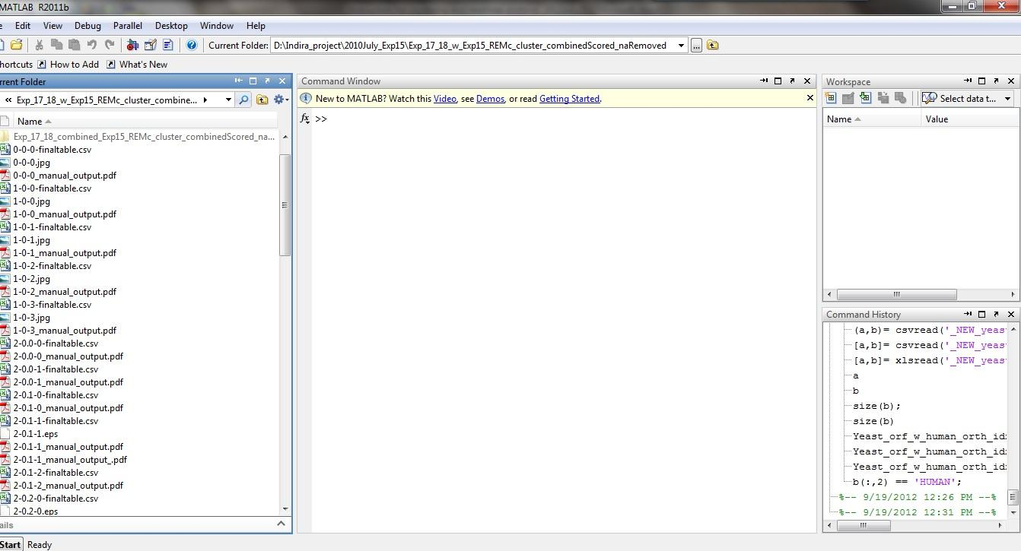
You can notice the left panel as the working folder panel to navigate in the file systems of your computer. The middle panel is the Matlab console, which acts like a python interactive shell or interpreter. You can also run the Matlab script (".m" file) from Matlab console.
The Matlab code to plot the heatmaps are four pieces:
a. parse_clusters_and_plot.m ( the main file to run, takes the inputs)
b. heatmapsAsWhole_sketchoutput_function.m ( the function for plotting and saving heatmaps )
c. generate_labels_array.m ( a special simple function to generate labels as arrays for heatmaps)
d. MyColormaps.mat (a colormap data matrix used for plotting. Can be edited using colormap editor GUI in Matlab.)
To run the code, put these four pieces together in the working folder, as well the input files (the separated "-finalTable.csv" files for clusters from the python code). Then, navigate to the working folder in Matlab (yes, use the left panel in Matlab). You should be able to see all the files from the left panel. Then, in the Matlab console, type in:
>> parse_clusters_and_plot
Just the main file name ( you can type a few letters and use Tab key for auto complete function) and Enter. Then Matlab will pop a file selection window. You can choose multiple input data files at the same time (using Ctrl and/or Shift key or Mac user "the flower key").
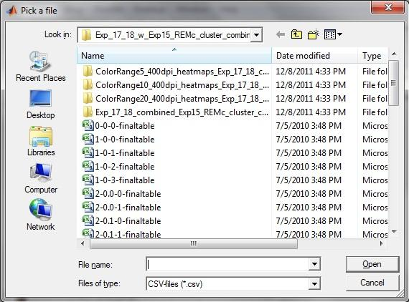
Then Matlab will ask for a few parameters, as such:
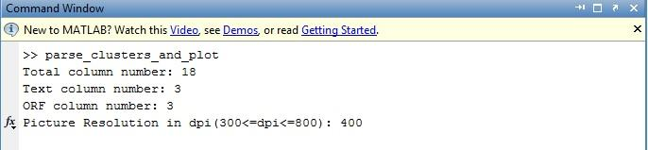
Four parameters here are:
a. Total column number (how many column in the table before the "cluster origin" column)
b. Text column number (the last column number for the text -- before the first data column, normally 3.)
c. ORF column number (Actually I use this column for the gene/ORF name labels in the heatmaps, normally 3.)
d. Picture resolution in dpi (Give a number between 300 and 800. This only affects the JPEG file, but not the pdf file.)
Then sit back and relax for a few more minutes. This piece of code consumes the physical memory very fast as it will plot one heatmap for each input cluster data file on the screen. I would suggest running it without other ongoing intensive computation tasks. Two files will be saved for each heatmap plotted -- one JPEG file and one PDF file in the working folder. Then you may have a lot of heatmap windows to close.
Note: the labels on the screen may be shown as scrambled but should look differently in saved JPEG and PDF files.

3. Run the Gene Ontology Term Finder (GTF) Perl code in a Linux terminal.
3.1. Background
Gene Ontology (GO) is like a comprehensive annotation/vocabulary system to all genes in an organism. For each gene, the possible annotations, which are specified as gene ontology terms, could be categorized into one of these three aspects: 1. F: molecular function; 2. P: biological process; 3. C: cellular component. The GO terms, as specified by an ID number (e.g. GO:000XXXX or similar) and the term content (e.g. translation, ubiquitin-related protein degradation, ATPase, mitochondria etc), are organized in one hierarchical structure within above three aspects (So these three aspects are also noted as the root term in the hierarchy of other GO terms) and more specified GO terms (for example: biological process -- translation -- translation initiation ... ). Each gene could be annotated by more than one GO terms in each of the three hierarchies. These three aspects represent: 1. F: molecular function -- biochemistry characteristics of these genes and their RNA/protein products; 2. P: biological process -- defined biological function annotated as sub/cellular level function; 3. C: cellular component -- cellular organelle location of RNA/protein products of genes. In our analysis, we mainly focus on understanding how gene modules may impact cellular function, and therefore we use mostly the biological process category of GO information.
The GO Term Finder algorithm was developed to find out the enriched annotated GO terms within a gene list compared to the genomic background for each GO term. The algorithm was originally developed in Perl (http://www.ncbi.nlm.nih.gov/pubmed/15297299 , and for downloading the Perl code package http://search.cpan.org/dist/GO-TermFinder/lib/GO/TermFinder.pm) but can only look for GO Terms for one list of genes each time. Chris Johnson at Dr. Brett McKinney's group made a shell script to loop this GTF code over a set of gene lists and generate the GTF result for the whole set of gene lists at once. However, this shell script can only be run from a Linux terminal (It may work in Mac as well but I never test it -- either Linux or Mac should have Perl installed. ) Shell is a Unix/Linux platform command processor, which serves as an interface between users and kernels of Unix/Linux. A typical shell version is Bash (Bourne-again shell), which should be compatible with this piece of code.
GTF package should be downloaded (http://search.cpan.org/~sherlock/GO-TermFinder/) and installed .
To analyze gene modules using GO information, one also need an input list of ORF names for a gene module/cluster (or a set of lists), downloaded two files for input as well: gene_association.sgd (To download this file, go to http://www.yeastgenome.org/download-data/curation and find the compressed file "gene_association.sgd.gz". Download and unzip it into your working folder) and "gene_ontology.obo "(http://www.geneontology.org/ontology/). These two files are updated continuously so better use most current version. Another required file is the ORFs_pool.txt or ORFs_w_DAmP_list.txt, which was also used in REMc, as the background file for GTF.
This GTF analysis requires basic command line operation. Three pieces of code are required: 1. example_v4.sh (Bash script, the main piece to run from shell); 2. analyze_v2.pl (Perl code, will be executed by the example_v4.sh Bash script to retrieve GO information from the obo file and form a intermediate .term file in the working folder); 3. terms2tsv_v4.pl (Perl code, will be executed by the example_v4.sh Bash script to convert the .term files into .tsv tab-delimited table file for each gene list). The input gene list(s) are generated when you parsed the REMc finalTable result file with the python code described in section 2.2 .
3.2. Set up the software environment for running GTF ( only do this step in the first time)
Four perl packages are required for installing and running the GTF (It seems like if you run Ubuntu Linux, you don't need to install the following packages before you can install GO-Term Finder.)
1. cpan package
2.Module::Build
3. File::Map
4. ExtUtils::MakeMaker
To install CPAN, in Fedora Linux terminal (sudo privilege required):
>sudo yum install perl-CPAN
<sudo password>
some questions may come up in the middle of installation. Use defaulted setting (hit "Enter").
Then, to install the other packages, by the prompt:
>sudo cpan -i Module::Build
>sudo cpan -i File::Map
>sudo cpan -i ExtUtils:MakeMaker
Then please go to http://search.cpan.org/~sherlock/GO-TermFinder/
and download GO-TermFinder-0.86 package in a compressed .tar file. Unzip it. Then direct the working folder to the unzipped GTF folder (Say unzipped to /workingFolder/GO-TermFinder-0.86)
>cd /workingFolder/GO-TermFinder-0.86
Then add the executable privilege to the Makefile.PL file by doing:
>chmod u+x Makefile.PL
Then to install GO-TermFinder, do (sudo privilege required):
>sudo perl Makefile.PL
<sudo password>
>sudo make
>sudo make test
>sudo make install
There might be a few questions pop up during the installation but can be proceeded by using the defaulted choice (just hit "Enter" when asked).

3.3. perform GTF
These code files should be put in the working folder:
example_v4.sh
analyze_v2.pl
terms2tsv_v4.pl

along with these files in the folder:
gene_association.sgd
gene_ontology.obo
ORFs_pool.txt or ORFs_w_DAmP_list.txt

To perform the GTF in Bash, one need to give executable privilege to each pieces of the script by the prompt of the shell ( you only need to do this once within the working folder ) .
>chmod u+x yourCodeFullPathAndFileName

Replace "yourCodeFullPathAndFileName" by "example_v4.sh analyze_v2.pl terms2tsv_v4.pl"

Then, at the prompt of the shell, do :
>/WhateverAbsolutePath/example_v4.sh backgroundFile /WhateverAbsolutePath/geneListFolder/genelist.txt
or
>./WhateverRelativePath/example_v4.sh backgroundFile ./WhateverRelativePath/geneListFolder/genelist.txt
You can use either relative path or absolute path ( don't forget relative path starts with a dot '.' ). If you have more than one gene list in the same folder (it is always advised to put all gene list .txt files from one REMc analysis in the same folder), use '*' to match all of them, for example:
>./WhateverRelativePath/example_v4.sh ./ORFs_pool.txt ./WhateverRelativePath/SampleExperiment/*.txt
if you use '*' to match all gene list .txt files, make sure you don't get another .txt file in the same folder or you get your code crushed.
The code may take a while to run as it involves some hard drive write and read. When it is done, there are two files generated for each gene list you input. One of them is a .term file and the other is a .tsv table file.

3.3. Parse the result into readable format
Updated (2013/03):
This paragraph describes an upgrade on the existing "Parse_GTF_result.py" code. It will also show the cluster size, LL and GOid_z score along with GTF result summary. The only issue is that it may not give as clear looking hierarchy of the REMc clusters as previous version -- so some spacer rows should be added manually.

It should be run similarly to the previous version except it requires one extra input file, which is the "wholetree" csv file from REMc Java code output.

To run it (only do the chmod line at the first time you run it, then you can just direcly run it with the second python line in the shell):

>chmod u+x Parse_GTF_result.py
>python Parse_GTF_result.py <GTF_result_path(a directory containing only the tsv files> <REMc_wholetree_file_path_and_name> <output_file_path_and_name>

The existing concatenate python code " Concatenate_GTF_results.py " remained unchanged from last version (2012/12).

Previous (2012/12):
The .tsv files contain similar output as from SGD GTF tools. The next step of GO analysis is to conclude the GTF results into one summary table and concatenate the GTF results for a set of REMc clusters. These two things can be done with two pieces of my python code: 1. Parse_GTF_results.py (to make the summary table); 2. Concatenate_GTF_results.py (to make the concatenated table of GTF results for each cluster, ranking by their hierarchy).
One need to give executable privilege to each pieces of the code by the prompt of the shell.
>chmod u+x PythonCodeFullPathAndFileName

Then, to run them:

>python Parse_GTF_results.py /datasetPath /outputFilePath_and_Name

and

>python Concatenate_GTF_results.py /datasetPath /outputFilePath_and_Name

The result files can be found in the indicated outputFilePath (only the directory should be given but not the GTF result files names. The code then can locate the files by itself), and the output files should be named with .tsv appended and can be opened using Excel.

4. Run other code to generate necessary files for above analysis.
These steps are required whenever the gene ontology information is needed to be updated. It can only be performed as the described fixed order since each step may require some output from the previous step. These updates regarding GO information has no direct connection to GTF analysis as described above in section 3, as it only provides the evaluation to the cluster quality. Nevertheless, it would be nice to keep GO information consistent throughout one analysis. Most GO repositories including the " gene_association.sgd" file from SGD are updated daily to keep the most current records according to Gene Ontology Consortium (where you might get the gene_ontology.obo file). On the other hand, however, it is not necessary to keep every analysis with most current GO information -- there won't be much difference using a six-month old repository of GO.
4.1 Make random cluster collection by different sizes
This step is done by using python code "create_random_collection.py" in *nix. One would need the file "ORFs_pool.txt" or "ORFs_w_DAmP_list.txt" as the input list.
>chmod u+x create_random_collection.py
>python create_random_collection.py input_list size_range interval outputPath
"size_range" and "interval" are two parameters that defines the series of sizes and the "outputPath" is a self defined directory that would be created during and contains output files after running the code.
The "size_range" can be used as "5,10,20-1500" and make "interval" as "20". This will create output gene lists with 5 ORFs, 10 ORFs and 20, 40, 60, ... to 1500 ORFs (20 as the interval). Please do notice there is no space in "5,10,20-1500". (also there is no quotation marks)

4.2Convert sgd GO information into attribute Table
This is done with python code " convert_sdg_to_attributeTable.py " in *nix (One can make Windows version if interested). One needs the gene_association.sgd file. To download this file, go to http://www.yeastgenome.org/download-data/curation and find the compressed file "gene_association.sgd.gz". Download and unzip it into the working folder.
To run this code, in the working folder, type in the shell:
>chmod u+x convert_sdg_to_attributeTable.py
above is to authorize the executable right to the python code " convert_sdg_to_attributeTable.py". To run this same piece of code in the future, above step is unnecessary.
>python convert_sdg_to_attributeTable.py gene_association-<version/date>.sgd OutputFolderPath IntermediateTableFileName GeneByGOAttributeMatrix_nofiltering-<version/date>.tab
The python code takes a few parameters:
a. the unzipped gene_association.sgd file, which was downloaded from SGD.
b. an output directory/folder to store the result attribute table and an intermediate file required for making the attribute table.
c. Intermediate Table File Name with .tsv . A file name to identify the intermediate table. The table has no other use than a middle step of making the attribute table -- it was output first to save memory (and partly because I do not want to change but only build upon Dr. McKinney's function). You can delete it after you get the attribute table.
d. A filename for the output suffixed by .tab for the Gene by GO Term attribute table. I suggest following the example as it will be used in the REMc Java code running. It would be better to keep it neat and tractable all the time. "GeneByGOAttributeMatrix_nofiltering-<version/date>.tab"
It takes 15 to 30 seconds to run and then you can find the attribute table (and the intermediate table file) in the output folder.
4.3 calculate rawGOid for 1000 random clusters
Note:This step is mainly done by running a few pieces of python code on cluster computer. For the basics of working on a cluster computer, please refer to section 5 of this instruction and other necessary information.
The GOid_z calculation in REMc clustering, if not performed as "real time", is done utilizing two functions that calculate the average and standard deviation of raw GOid scores of 1,000 randomly generated clusters at each of a variety of cluster sizes. Since the calculation is based on raw GOid, it is NECESSARY to update these functions every time the Gene Ontology information is renewed in the GeneByGOAttributeMatrix file (as described in section 4.2). This requires using some high performance computation tools( described in section 5). To update the function in REMc Java code for GOid_z calculation, we need to generate raw GOid scores for 1,000 randomly generated clusters with each of selected cluster sizes using python code (on cluster computers) before to parse these raw GOid scores in python (can be done on a desktop or laptop) and output average and standard deviation for each size in Excel; then we need to perform curve fitting using Matlab code and update the function from curve fitting in REMc Java code.
1, generate raw GOid scores for 1,000 randomly generated clusters with each of selected cluster sizes using python code (on cluster computers)
The following files are required in the working folder:
1, create_qsub.py
2, runQsub.sh
3, GeneByGOAttributeMatrix_nofiltering-<version/date>.tab
4, ORFs_pool.txt or ORFs_w_DAmP_list.txt
5, Make a subfolder in working folder that contains the random cluster collection generated in previous step.
6, an empty subfolder in working folder to take the 1000 random clusters for each sizes.
One needs to run a python script on the head node to create the qsub jobs. The code is 'create_qsub.py'. This piece will create a series of 'qsub' job to other nodes, in each of which another python job
'relative_cluster_entropy_background_withcluster_v5.py ' will be created for each size of random clusters. The ' relative_cluster_entropy_background_withcluster_v5.py' will call other python code and use input files to assist the rawGOid calculation.
So, to create qsub jobs, you need:
create_qsub.py

This piece is called by create_qsub.py:
runQsub.sh

The python codes required for rawGOid calculation are:
relative_cluster_entropy_background_withcluster_v5.py (the main function called by the runQsub.sh and some parsing is included.)
information_class_v2.py (the information divergence and entropy definitions)
random_cluster_sample.py ( write the 1000 random clusters)
random_cluster_sample_v2.py (replace any random cluster from the 1000 if no significant GO term is associated. This step is most likely to be needed by only small size clusters, like 3-5 genes -- however, this step can introduce slight to none bias.)
stats.py (some statistics used by the process)

To setup the running on Cheaha, here is an example line running on head node to create 77 qsub jobs ([5,10,20,40,...,1000,... 1480,1500]):
>python create_qsub.py ./randomClustersDamp/ 5,10,20-1500 20 ./sampleRandomClusters2/ GeneByGOAttributeMatrix_nofiltering-2012Dec06.tab ORFs_w_DAmP_list.txt

To explain a bit here:
>python create_qsub.py clusterSeedingSampleFolder/ sizeRange intervalForSizeRange emptyFolderFor1000TempRandomClusters geneByAttrTable ORFsList
"sizeRange" and "interval" are two parameters that defines the series of sizes. The "sizeRange" for example can be used as "5,10,20-1500" and make "interval" as "20". This will create output gene lists with 5 ORFs, 10 ORFs and 20, 40, 60, ... to 1500 ORFs (20 as the interval). Please do notice there is no space in "5,10,20-1500". (also there is no quotation marks)
After running, the results are a series of single files collected in the clusterSeedingSampleFolder and named as size???.txt.GOid.txt .
A few things to note:
a. Each job set up on the Cheaha is limited by a server time. By default, it is 15 minutes. If one need longer run time before mandatory termination of the job, he should point out in the qsub shell script as
#$ -l h_rt=4:00:00
Above is an example for maximum 4 hours runtime, which is used in my current version of 'runQsub.sh' and enough for current Gene Ontology repository. In case GO repository increases in the future, please increase the maximum runtime accordingly.
b. Each qsub job is assigned with one priority score, which determines the chance to get a node running it (nodes are dynamically assigned using the priority score). Please realize that unnecessary excess runtime will lower down the priority score of the job and make it less likely to be run earlier. Normally, 2-30 jobs can possibly be awarded nodes at the same time depending on how the overall workload of the cluster server. The rest submitted jobs will be kept in a queue for next available nodes.
c. Currently, a job with rawGOid calculation on 1000 random clusters takes 2.5 - 3.5 hrs to run (mainly depending on which ORF list used).
d. Start each run with a small amount of jobs (3-5) to test if everything is right before submitting every jobs.
e. There will be two flow recording files written in working folder associated with each job. One of them records terminal output and named with 'RelaClustEntropy .o??????' . The other one records error flow and named ' RelaClustEntropy.po?????? '. After jobs are finished, one can delete them using :
>rm RelaClustEntropy .*
f. For some information regarding how the runQsub.sh for Cheaha should be constructed, please refer to https://docs.uabgrid.uab.edu/wiki/TopHat

4.4 parse the rawGOids for 1000 random clusters and get the fitting curves for mean and stdev
This step are divided into two: 1, run python code to collect and parse the size???.txt.GOid.txt files into one table containing three columns: size, mean of 1000 rawGOids of random clusters, stdev of 1000 rawGOids of random clusters; 2, run curve fitting Matlab code to get the functions and update the REMc Java code.
To parse the size???.txt.GOid.txt result files, all of which should be downloaded to a local folder. In a *nix terminal prompt, do:
>chmod u+x parse_random_rawGOid_results.py (as before, do this only the first time)
>python parse_random_rawGOid_results.py resultFilesFolder outputFolder outputFileName
The resultFilesFolder is the local folder where you store all size???.txt.GOid.txt files. outputFolder can be any folder you want. outputFileName is a string you want to name the output file, which should be a .csv file (comma delimited). However, you don't have to specify .csv in the outputFileName parameter.
It takes a heart beat for the code to finish and a new .csv file should be found in the indicated folder. The .csv file can be then feed into curve fitting Matlab code for the fitted function.
The Matlab curve fitting code (Curve_fitting.m) utilizes non-linear model specified in the non_linear_fitting_model.m function file. The code will read one .csv file created by above python code.
In a Matlab console, navigate to the working folder, where the Curve_fitting.m and non_linear_fitting_model.m are located. Run the code from the console:
>Curve_fitting
Then a window as shown in the picture pop up to pick the .csv file:
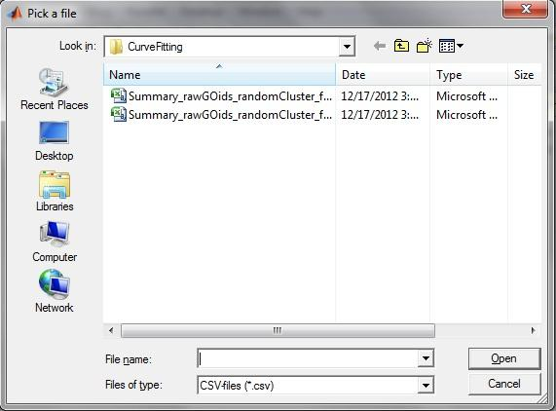
Choose the csv file created by the above python code. Then two plotting panels are shown ( they came out overlapped)
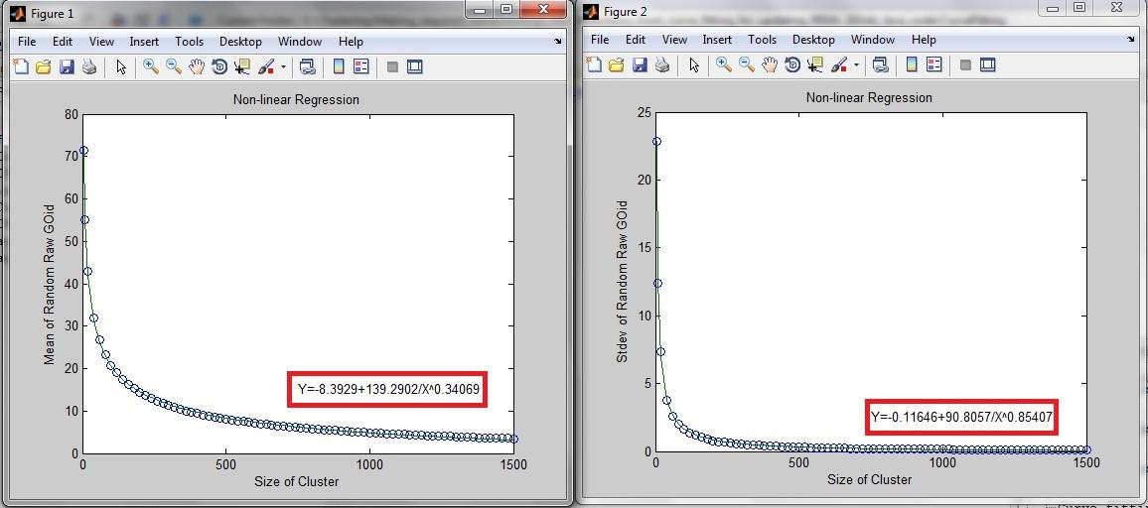
One of those two panels is for the mean of random rawGOids, and the other is for standard deviation of random rawGOids. The functions indicated in the red boxes can be used to update the functions in the Java REMc code.
In the Stats.java file, look for the following two sections (first section for mean, second for stdev), and put the functions from above curve fitting as a line look like this:
return ( ???? + ???/Math.pow(size, ????));
I kept previous functions in the source code without affecting the integrity of the code by making them comments (adding '//' in front of the line will label the whole line as comments). Java will ignore the comments during compiling. After updating, save the file before executing or exit.
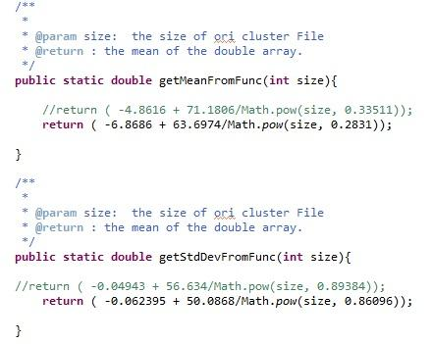
5 Work on high performance computer cluster
5.1 Background
This is an in-depth topic for a beginner as it involves some understanding of shell and working knowledge on a cluster, however, it is necessary to use cluster if one wants to do real time calculation of GOid_z during the clustering. I will provide some information here to run the Java code but the user should be responsible to learn how to work on a cluster computer.
One need username and password for remote login on a cluster. UAB still provide scientific computation service from a cluster named 'Cheaha' (https://docs.uabgrid.uab.edu/wiki/Cheaha) at cheaha.uabgrid.uab.edu . The Olympus cluster from computer department is no longer available.
It is possible to access Cheaha from a Terminal from *nix system. Here is some information (http://me.eng.uab.edu/wiki/index.php?title=Cluster_login)
Windows user may need a secure shell client software, which will not be further discussed in this instruction. However, Windows system is poorly compatible with Unix system running on Cheaha, for example, ^M is DOS line break character which shows up in Unix files when uploaded from a Windows file system in ascii format (^M is shown as '\r' in most Windows text based files). Therefore, it is recommended that you perform and edit the code via and in a *nix system. (you will know it when you get so advanced that you can still make programming sound in windows.)
Also be careful with the spaces you typed in. The number of spaces may matter in some occasions.
5.2 connect from local computer (*nix) to Cheaha and transport files in between (Internet connection required).
To login, in Terminal, type in:
ssh username@cheaha.uabgrid.uab.edu
Then input the password (potentially your BlazerID and BlazerID password. The first time login requires to answer 'yes' to the RSA key installation on local computer), and now you logged into the head node of the cluster and have the access to other sub-nodes. The prompt on the Terminal window is now by Cheaha. Any command you type in now is to operate on Cheaha.
Leave the Cheaha login Terminal open, and start another Terminal for files transportation. In the new Terminal, for upload files to Cheaha:
[jguo@cheaha ~]$ scp localpath/filename username@cheaha.uabgrid.uab.edu:~/whatever-destination-directory/
To download files:
[jguo@cheaha ~]$ scp username@cheaha.uabgrid.uab.edu:~/some-cheaha-directory/filename /whatever-local-directory/
Password are required each time with scp command. I strongly suggest one to create a folder as a home directory on local computer to duplicate whatever in your login directory on Cheaha. You can use string operator '*' or '?' to upload or download a group of files (your code, data files, and supporting files) with one command.

5.3 Moving around in the file systems
Once logged in the Cheaha, one is in the home folder '~/'. To move down to a deeper directory, use 'cd' (change directory):
[jguo@cheaha ~]$cd <subfolderName>
To move up:
[jguo@cheaha ~]$cd ..
There is a space before the two dots.
To show what is in current folder, use 'ls' (list):
[jguo@cheaha ~]$ls
To show in more details (this varies by Unix or Linux versions):
[jguo@cheaha ~]$ls -l
or
[jguo@cheaha ~]$ls -all
A tip is when you type a folder name or file name, after a few letters you can hit 'Tab' key to allow *nix auto-complete the name for you.

5.3. Manage the jobs
To lookup the job status:
[jguo@cheaha ~]$qstat
This will pull up a table detailed with each job submitted but not finished.
To delete a job or a few:
[jguo@cheaha ~]$qdel [jobIDs]
the parameter here is a list with numeric IDs delimited by comma ',' for jobs to be deleted. No space in the list but comma, such as:
qdel 12345,54321
To delete all job submitted by a user;
[jguo@cheaha ~]$qdel -u <username>

6. Prefuse Treeview REMc viewer (not ideally functional yet)
Prefuse Treeview REMc viewer is an in-house development to interactively visualize the hierarchical REMc structure and heatmaps based on Prefuse package. Prefuse is a Java-based toolkit for building interactive information visualization applications. It supports a rich set of features for data modeling, visualization and interaction. (http://prefuse.org/)
This Prefuse Treeview REMc viewer was drafted by Dehua Tian from McKinney group. It was pretty "hard" coded (which means the parameters are not taken by the code from the user but the corresponding parameter information are written in the code).
The code is done in Java and therefore can be performed in Eclipse (refer to section 1 for Eclipse installation and setup)
Create the project for "Prefuse_treeview". Copy the following code into the src folder under the project folder "Prefuse_treeview" in Eclipse working folder:
1, ShowPicture.java
2, TreeView.java
Then, copy the -tree.xml file generated in REMc to the "Prefuse_treeview" project folder.
Then, make a new folder named 'images' (the name and the case have to match) in the "Prefuse_treeview" project folder and copy the JPEG images of corresponding REMc clustering into the 'images' folder. Pictures are created by Matlab, refer section 2. The pictures have to be named by the original name and stored in the 'images' folder.
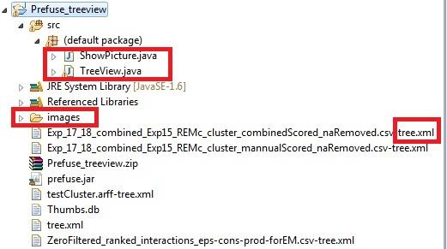
The code requires prefuse.jar to be functional. The prefuse.jar is used as an external lib that can be input similar to weka.jar for REMc.
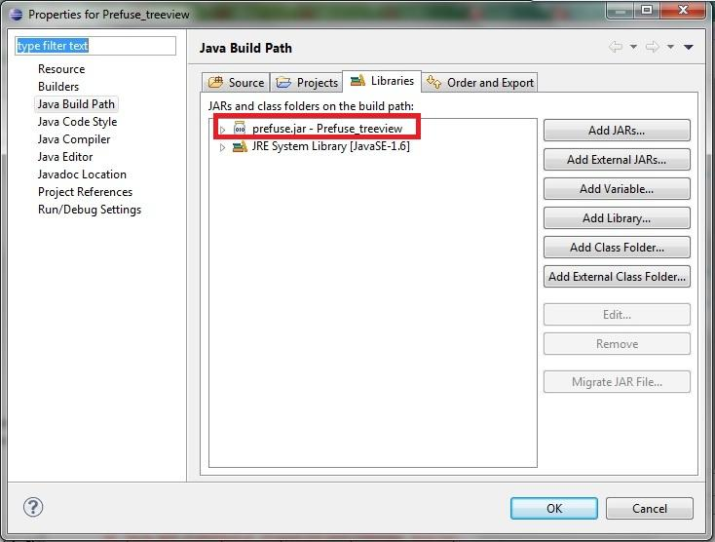
Also it may or may not be required to add the 'prefuse.jar' into Library by clicking on "Add Library" on the "Java Build Path" panel.
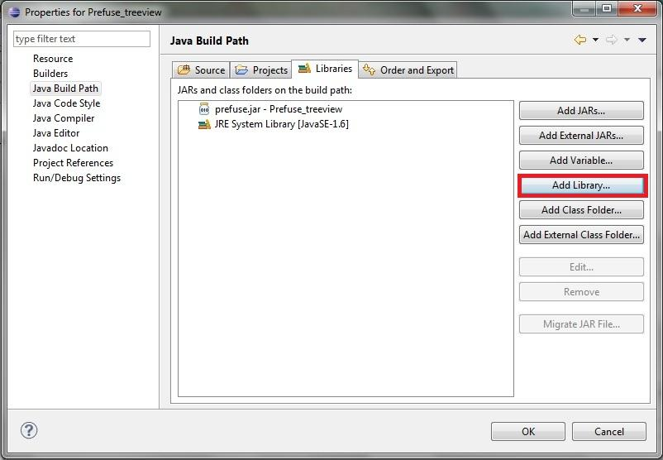
Then, in the new pop up window, choose "User Library" and click on "Next".
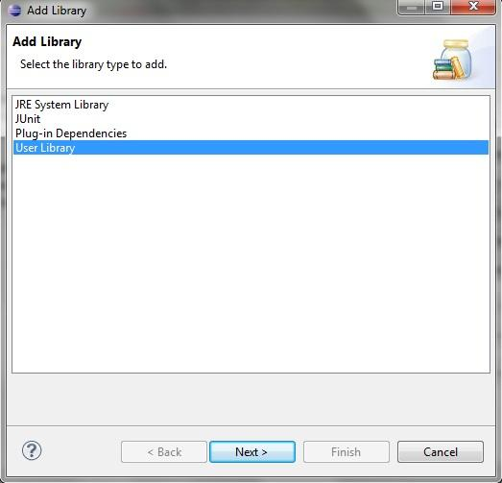
After select "User Libraries", a new window pop up, in which click on "New...":
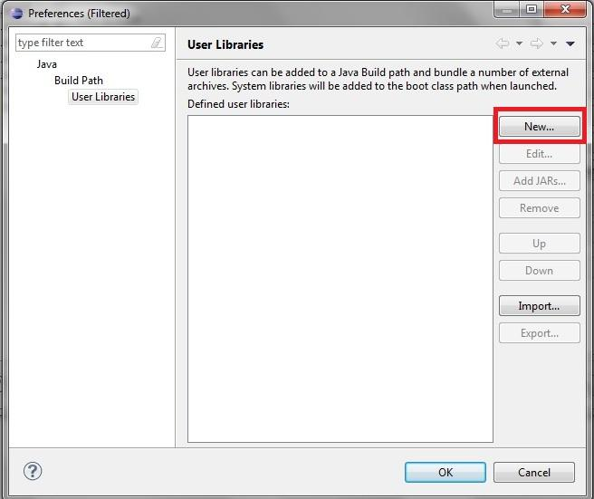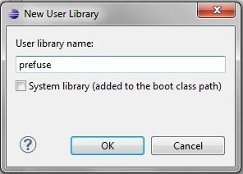
In the "New User Library" window, type in "prefuse" as the name, then click on "OK". Then the "User Libraries" window will look like following:
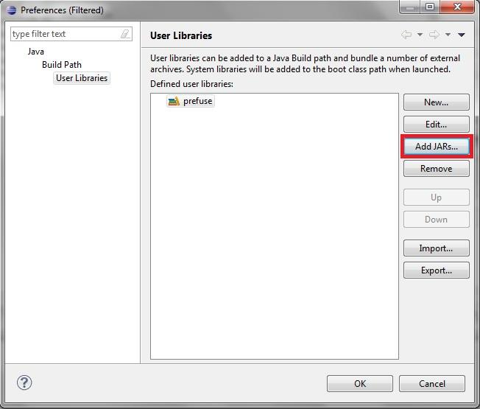
Then click on "Add JARs...", it would bring up a File Navigator named "Jar selection" as following:
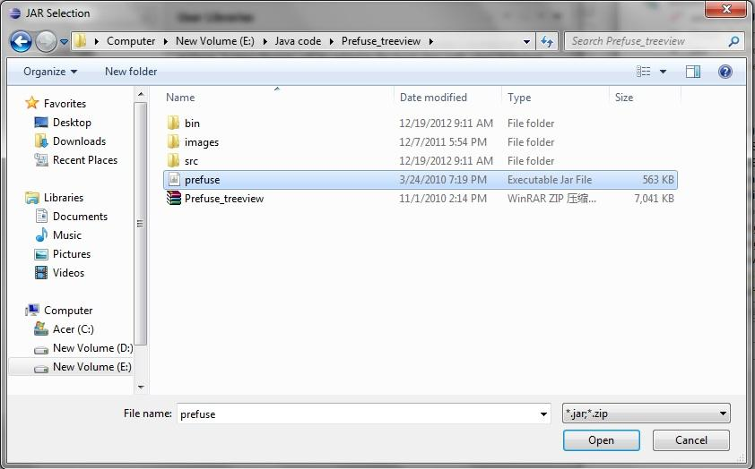
Find the "prefuse.jar" file and click on open. Then click on "OK" to close all windows. Now "prefuse.jar" is successfully added into Java Library.

To run the code, you need to give the -tree.xml file name as the first arguments for the Program arguments, and set the VM arguments to "-Xms128m -Xmx800m"
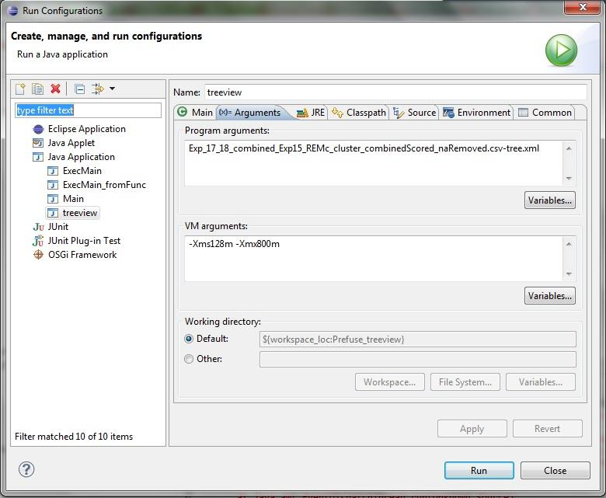

Click on run button to run the code, and a window will show up as following:
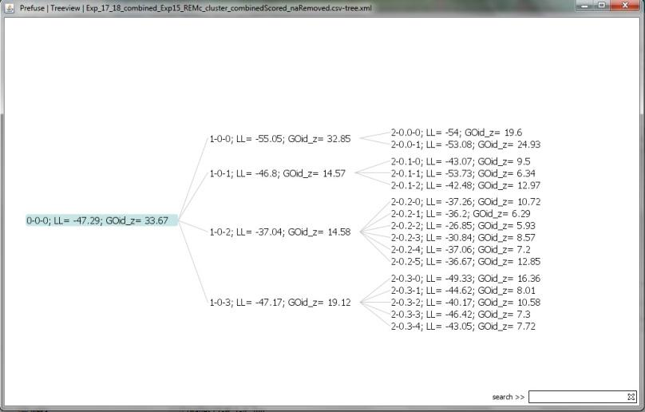
The REMc clusters are shown by its name, Log Likelihood score and GOidz score, as in a hierarchy structure. The mouse cursor move over the node (cluster) will bring up a sketch picture of the corresponding heatmap of the cluster. Double click on node will bring up the original picture of the cluster. Single click will also open up the tree further to show subclusters and ORF names. However, as it functions well as a program but not that useful for the investigation purpose.

